Task Documentation

Smarter Balanced Assessment Consortium Test Delivery System

Component: Test Delivery System

Purpose: Smarter Balanced Task Order 24

TDS Update for NFB Requests

Revision History

|  |  |  |
| --- | --- | --- |
| **Revision Description** | **Author / Editor** | **Date** |
| 1.0 – First release. | Rami Levy | Dec. 12, 2016 |
| 1.1 – Added repository change table (Section 7). Removed one backlog item (Section 5) and added new backlog item in Section 5.6. Formatting changes, updated missing photos, and added description of task documentation location (Section 7). Added information regarding the addition of a merged code branch to each of the repositories. | Rami Levy | Dec. 13, 2016 |

­­

Contents

1 Overview 4

1.1 Solution Description 4

1.2 Scope of Work 4

1.3 Out of Scope 4

1.3.1 Secure Browser 4

1.3.2 Text-to-Speech (TTS) Support for non-Secure Browsers 4

1.3.3 System Testing 4

1.4 Deliverables 4

2 Requirements 6

3 Design and Code Change Descriptions 8

3.1 Student Help Guide Updates – SB-1503 8

3.2 Navigational Improvements for Next Button – SB-1504 8

3.3 Restructuring of the Student Interface UI – SB-1505 9

3.3.1 General Screen Layout 9

3.3.2 Button Order 10

3.4 Intelligent Muting Capability – SB-1506 11

3.5 Other Related Changes 11

3.5.1 Support for Formative Tests – SB-1508 11

3.5.2 Elimination of Unused Dependencies – SB-1509 12

4 Source Licensing 13

5 Known Issues and Backlog Items 14

5.1 JAWS Radio Button Handling 14

5.2 Safari Quick Nav 14

5.3 Safari Keyboard Navigation to Tool Menu 14

5.4 Auto-Request Embossing 15

5.5 Proctor Display of Student Test Settings 15

5.6 Missing Top Border in Test Review Screen 16

6 Appendix A: Before and After Student Screenshots 17

6.1 Login Page 17

6.2 General CSS and Page Layout 20

6.3 Login Verify 20

6.4 Test Selection Page 21

6.5 Accommodation Selection Page 24

6.6 Confirm Accommodation selection 25

6.7 Audio Playback Check Page 26

6.8 Sound Check: Audio Problem 27

6.9 Text-To-Speech (non-secure browser) 28

6.10 Text-To-Speech (Secure Browser) 29

6.11 Help Page 31

6.12 Test Page 32

6.13 Review Page 32

6.14 Result Page 33

7 Appendix B: Code Change Summary 34

Figures

Figure 1: New help icon 8

Figure 2: Quick Navigation NEXT button 9

Figure 3: General Student Screen Restructuring 10

Figure 4: New button layout, example 1 10

Figure 5: New button layout, example 2 10

Figure 6: Safari Preferences to Enable Keyboard Navigation 15

Figure 7: iPad review screen (left) vs. other browser (right) 16

Figure 8: Summary of Repository Changes 34

Tables

Table 1: Task Order 24 issues to address 7

Table 2: Actual TO-24 changes 8

Table 3: System Volume Options 11

# Overview

Upgrade the Open Source TDS student interface to a more consistent UI which provides improved support for Braille accommodations and better accessibility.

## Solution Description

The Open Source TDS student interface will be updated to improve accessibility and correct certain related issues. These changes will be merged from the AIR Proprietary TDS's Student front-end.

* Student login, test, and review shells updated to align with AIR Proprietary TDS. This includes improvements to navigation and accessibility.
* Help files and other documentation updated and corrected to improve accessibility.
* Add intelligent muting capability.
* Fix various accessibility-related issues.
* Updated TSB side-loading script to support appropriate test types and existing P&T tests.

## Scope of Work

* The code changes affect only the Student application and some associated shared code.
* Unused dependencies in Student and Proctor WAR file are to be removed.
* Documentation changes which affect existing documents.
* Unit and integration testing, including test cases.

## Out of Scope

### Secure Browser

Some solutions require changes in the Secure Browser (i.e. the use of Secure Browser 9.0+). This version of the Secure Browser is not included as part of the deliverables of this task order. However, appropriate changes in the code will be made to support the use of SB 9.0+.

### Text-to-Speech (TTS) Support for non-Secure Browsers

TTS has never been supported in the Open Source TDS when using a browser other than the Secure Browser, unlike AIR's proprietary TDS where it is supported. This continues to be the case after this release, as this was not a requested change.

### System Testing

System testing or a system test plan are not included as part of the deliverables for this task order.

## Deliverables

All deliverables will be made available via the GitHub SmarterApp repository.

* Description of all changes (this document);
* Source code will be provided on branches in Github SmarterApp repositories, but will not be merged into master branch. A pull request will be made to the *develop* branch on each affected repository. Additionally, a merged branch per repository of all code changes will be added as branch TaskOrder-24;
* Integration Test plan and test cases;
* Project dependency list for Open Source license verification (proctor and student);
* Backlog documentation, if any (available within this document).

# Requirements

Task Order 24 requirements, along with the proposed fixes, are shown in Table 1.

* Tasks with a white background represent changes to be made in this TDS release.
* Tasks with a tan background represent changes available only with Secure Browser 9.0+.
* Tasks with a gray background items represent issues that were not reproducible and therefore considered resolved in the current and released version of Open Source TDS.

|  |  |  |  |
| --- | --- | --- | --- |
| **No.** | **Problem** | **Proposed fix** | **Fix in** |
| 1 | JAWS perceives the question mark as punctuation and does not vocalize it. | For Help button[?], just use an image with an alt tag. | TDS |
| 2 | Update Help Guide text to remove reference to question mark [?] | Correct in help guide contents | TDS |
| 3 | Improve speed of navigation when moving to the next item after answering last question on a page, by avoiding having to tab all the way to the Next button. | Add ability to get to the "next" button immediately following answering the question instead of needing to navigate to the top of the question. | TDS |
| 4 | Login, Test Shell, and Review shell - ensure proper ordering of headers/sections (H1/H2 etc.) and improve consistency | Merge latest front-end code to create distinct sections that improve readability and accessibility. | TDS |
| 5 | ELA tests are always muted in Braille mode | Implement intelligent muting capability – mute all, mute items only, mute passages only, or mute none.[1] | TDS |
| 6 | On Win Vista/XP machine, Secure Browser 8 was toggling through the language input when the Window logo key was pressed. | Make Window logo key not do anything (secure browser fix). | Secure Browser 9 |
| 7 | Task manager remains disabled when SB exited abnormally. | Do not disable Task manager, user switching, and Lock when running in Enterprise edition of any Windows OS as long as user is an admin. Fix in Secure Browser | Secure Browser 9 |
| 8 | Usability, Accessibility, and Accommodations Guidelines | http://www.smarterbalanced.org/wp-content/uploads/2015/09/Usability-Accessibility-Accommodations-Guidelines.pdf - Not an AIR document. | Documentation |
| 9 | Braille Requirements and Testing Manual | https://airassessment.knowledgetree.com/01jys has already been updated. | Documentation |
| 10 | Zooming in/out using +/- on nav menu did not cause nav icons/components to zoom accordingly. | Adjust nav icons/components to zoom accordingly when zooming in and out. | TDS |
| 11 | (Test Settings) Labels aren’t being read when tabbing to accompanying input elements | Ensure labels are read. | TDS |
| 12 | New Presentation and Labels are not read from each Drop Down (old complaint) | Could not reproduce, but possibly a duplicate. | TDS |
| 13 | (Test Instructions and Help Page) JAWS reads the TTS buttons for the help guide, but should not | Hide TTS buttons so that JAWS would not read them out loud. Requires use of JAWS and Braille Mode. | TDS |
| 14 | (Test) Context menu opens, but JAWS doesn't read context menu, instead continuing to read the content. | Read he context menu when it opens. | TDS |
| 15 | Address periodic JAWS error when switching test screens from one page to the next. New page was displayed, but JAWS was reading a previous page | Correct in TDS | TDS |
| 16 | Address the manner that JAWS reads MS checkboxes (reads) as radio buttons | Correct in TDS | TDS |
| 17 | Address issues with some of the tables in help guides | Add missing headers and/or captions in the tables in help guide content. | TDS |
| 18 | Address issue with the shortcut links in the help guide (not working well with screen reader). | Correct in help guide contents | TDS |
| 19 | Address MathML issue. Math ML is presented in Math tests instead of images with alt tags | Correct in TDS | TDS |
| 20 | Ensure focus starts in main region (not banners) after page turns | Correct in TDS | TDS |

Table : Task Order 24 issues to address

# Design and Code Change Descriptions

|  |  |  |  |
| --- | --- | --- | --- |
| **No.** | **Problem [JIRA-REF]** | **Proposed fix** | **Fix in repo(s)** |
| 1 | JAWS perceives the question mark as punctuation and does not vocalize it. [SB-1503] | For Help button[?], just use an image with an alt tag. | TDS_Student |
| 2 | Update Help Guide text to remove reference to question mark [?][SB-1503] | Correct in Help Guide contents | TDS_Student |
| 3 | Improve speed of navigation when moving to the next item after answering last question on a page, by avoiding having to tab all the way to the Next button. [SB-1504] | Add ability to get to the "next" button immediately following answering the last question on the page instead of needing to navigate to the top of the page. | TDS_Student  TDS_ItemRenderer |
| 4 | Login, Test Shell, and Review shell - ensure proper ordering of headers/sections (H1/H2 etc.) and improve consistency [SB-1505] | Merge latest front-end code to create distinct sections that improve readability and accessibility. | TDS_Student  TDS_ItemRenderer  TDS_TestDeliverySystemDataAccess |
| 5 | ELA tests are always muted in Braille mode [SB-1506] | Implement intelligent muting capability – mute all, mute items only, mute passages only, or mute none. | TDS_Student  TDS_ItemRenderer |
| 6 | Other: Formative test support [SB-1508] | DB and script modifications | TDS_Administrative |
| 7 | Other: Eliminate unused dependencies [SB-1509] | Modify POMs and remove related imports. | TDS_Student  TDS_Proctor  TDS_ItemScoring |

Table : Actual TO-24 changes

## Student Help Guide Updates – SB-1503

Table 2, items 1 and 2.

The problem is that JAWS does not read the "?" out loud, instead only reading *open paren close paren* or *open bracket close bracket* when it encounters (?) or [?]. The implemented solution is to replace the [?] by the actual help icon image, along with alt text describing it (see Figure 1). The changes are encompassed in three files that comprise the Smarter Balanced Student Help guide in TDS.

Other adjustments have been made to the Help Guide have been made to improve accessibility for the three versions of the help file that exist (Spanish, English, Streamlined). The internal reference ID (JIRA) for these changes is SB-1503. <https://github.com/SmarterApp/TDS_Student/tree/SB-1503-help-guide>

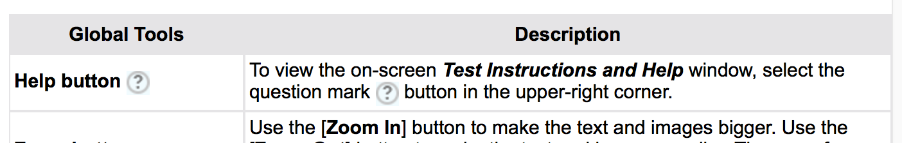

Figure : New help icon

## Navigational Improvements for Next Button – SB-1504

Table 2, item 3.

When positioned at the end of the last question on a page, it is cumbersome to navigate the cursor back to the top of the page using the keyboard, in order to get to the "Next" button. This fix creates a "Next" button which appears at the bottom of the page just past the end of the last question (see Figure 2). The internal reference ID (JIRA) for these changes is SB-1504.

<https://github.com/SmarterApp/TDS_Student/tree/SB-1504-BtnNextBottom>

<https://github.com/SmarterApp/TDS_ItemRenderer/tree/SB-1504>



Figure : Quick Navigation NEXT button

## Restructuring of the Student Interface UI – SB-1505

Table 2, item 4.

The student login, test, and review shell screens have been restructured for improved consistency, readability, and accessibility. Note that this changes the look and feel of the Student interface from what Smarter has known in the past. However, it does bring it in line with the existing Smarter Balanced Practice and Training site that has been available since July 2016, as well as with the AIR Proprietary student interface look and feel. The internal reference ID (JIRA) for these changes is SB-1505.

<https://github.com/SmarterApp/TDS_Student/tree/SB-1505-UI-Consistency-Enhancements>

<https://github.com/SmarterApp/TDS_ItemRenderer/tree/SB-1505-UI-Consistency-Enhancements>

<https://github.com/SmarterApp/TDS_TestDeliverySystemDataAccess/tree/SB-1505-UI-Consistency-Enhancements>

### General Screen Layout

The new screens follow a three-section format, as detailed below. Generally, the top section describes the page and provides instructions; the center section houses the main content, and the last section contains descriptions of the next steps (see Figure 3).

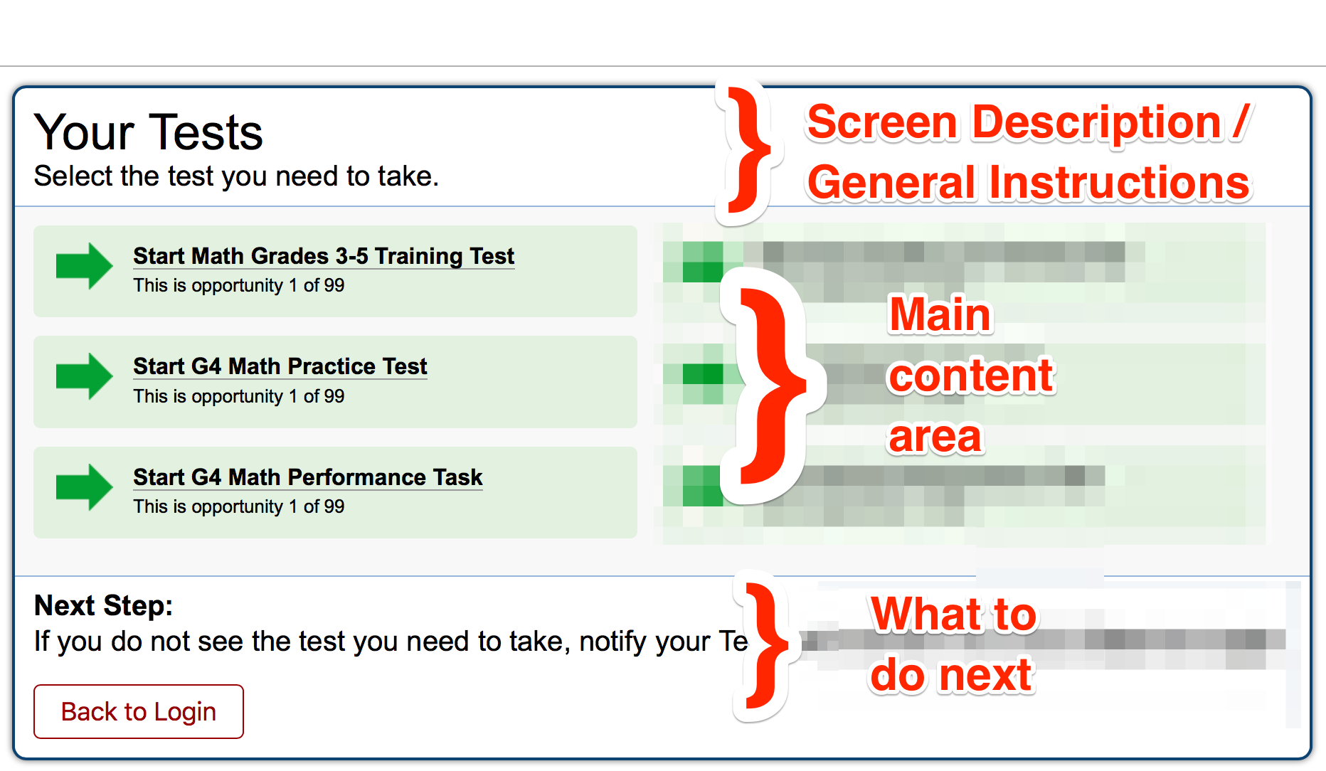

Figure : General Student Screen Restructuring

### Button Order

The new layout improves consistency by always placing the positive action button first (left), followed by the other buttons. For example, the *Yes* button will always precede the *No* button (and be the default), and *I heard the sound* precedes *I did not hear the sound*. See Figure 4 and Figure 5 for examples of this.

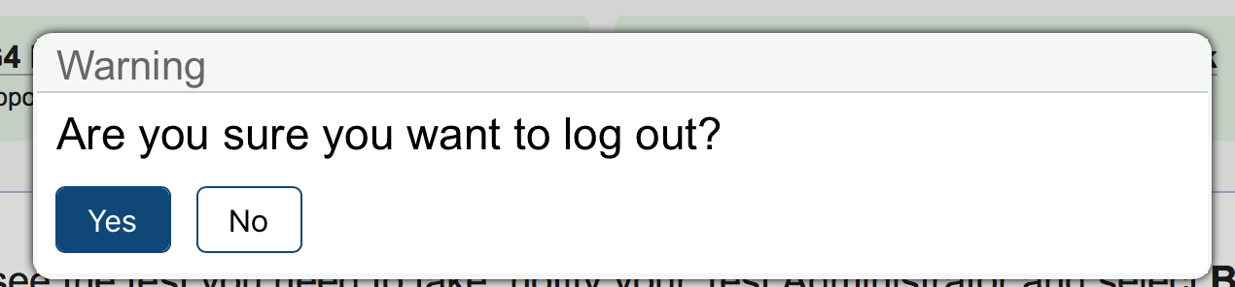

Figure : New button layout, example 1

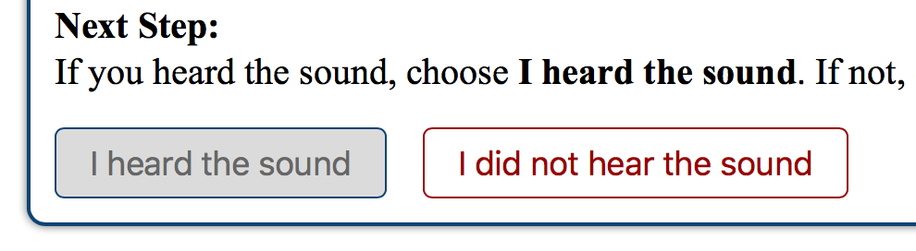

Figure : New button layout, example 2

To view before-and-after screenshots of the student interface, see Appendix A: Before and After Student Screenshots.

## Intelligent Muting Capability – SB-1506

Table 2, item 5.

Intelligent muting is a configuration (test level or proctor level) that allows the ability to (a) mute the entire test; (b) mute just passages; (c) mute just questions; or (d) don't mute anything. This was implemented with a new, custom tag (attribute) called *brailleonly* which is set to *true* for all item containers, or *true* for all passage containers, or both. This new attribute is only supported by JAWS 16+ and requires Braille mode to be active.

The brailleonly.js file that sets attribute *brailleonly* depends on the values of 'Mute System Volume' accommodation property derived from client_testtool table for given test. The configuration options are:

|  |  |
| --- | --- |
| Mute System Volume | Meaning |
| TDS_Mute0 | Not Muted |
| TDS_Mute1 | Muted |
| TDS_Mute2 | Only Read Passages Aloud (JAWS 16+ Users Only) |
| TDS_Mute3 | Only Read Items Aloud (JAWS 16+ Users Only) |

Table : System Volume Options

Here are the pre-requisite steps:

1. Install JAWS version 16 or above (Windows).
2. Two new tools need to be added to *client_tool* table in *configs_db* for tool type 'Mute System Volume' for the test in question.
3. Because ‘Mute system Volume’ tool depends on language, the corresponding record should be added or updated in *client_tooldependencies* table with the *isdefault* column assigned to 1.
4. If muting options are changed or added for any test by adding/updating records in client_tooldependencies and client_testtool tables, the following stored procedures must be executed to update cached tables:

* call configs._dm_clearaccomcache();
* call configs.__slugtestaccoms(null);

1. It is recommended to restart *Student* (or Tomcat) after doing this.

The internal reference ID (JIRA) for these changes is SB-1506.

<https://github.com/SmarterApp/TDS_Student/tree/SB-1506-Intelligent-Muting>

<https://github.com/SmarterApp/TDS_ItemRenderer/tree/SB-1506-Intelligent-Muting>

## Other Related Changes

### Support for Formative Tests – SB-1508

In the case where a single user role could include administration of all three types of tests (Summative, Interim, and Formative), several updates needed to be made.

1. TSB side-loading script load_reg_package.pl
2. Test packaging scripts (internal)
3. TDS database column *testtype* in *table r_proctorpackage* as follows:

alter table r_proctorpackage MODIFY testtype varchar(40);

This required change has also been documented in the Proctor and Student README files.

The internal reference ID (JIRA) for these changes is SB-1508.

<https://github.com/SmarterApp/TDS_Administrative/tree/SB-1508-allow-testtype-bypass>

### Elimination of Unused Dependencies – SB-1509

In the course of WAR validation, it was found that two dependencies needed to be removed from the Student and Proctor WARs.

* *neo4j* JAR (neo4j-cypher-compiler-2.1) is referenced in the student POM but is not referenced in the code. The result of this is its unnecessary inclusion of this JAR in the student WAR, and a license incompatibility with the rest of the code.
* *mysql-connector* JAR (mysql-connector-java) is a run-time dependency and should not be included in the WAR, but rather in the server's common.loader lib directory. This reference was removed from both the student and proctor POMs.

The internal reference ID (JIRA) for these changes is SB-1509.

<https://github.com/SmarterApp/TDS_Student/tree/SB-1509-Unused-Dependencies>

<https://github.com/SmarterApp/TDS_Proctor/tree/SB-1509-Unused-Dependencies>

<https://github.com/SmarterApp/TDS_ItemScoring/tree/SB-1509-Unused-Dependencies>

# Source Licensing

The source code provided in this task order is licensed under the AIR Open Source License v.1.0, as indicated in the headers of all source files. WAR dependencies have been checked for license compatibility in Student and Proctor. Documentation is provided along with this release in Student-dependencies.pdf and Proctor-dependencies.pdf.

# Known Issues and Backlog Items

The following issues were identified during the course of this task order and remain unresolved at this writing, as they are either outside the scope of the Task Order, already resolved in the master branch, or trivial.

## JAWS Radio Button Handling

In JAWS v.17, with TDS Student in Braille mode and a Refreshable Braille Display attached, it is possible to have a radio button be marked as *unchecked* on the Braille display (and as read by JAWS), when it has just been checked by the user.

**PROBABLE CAUSE**

This is a bug in the way JAWS handles some types of web based radio buttons

**WORK-AROUNDS**

Any of the below will work.

1. Use the JAWS “readline” function

2. Press the Braille routing key associated with the radio button a second time.

3. Use the enter key to select a radio button. (This will turn on forms mode.)

## Safari Quick Nav

There is a known issue with Safari v.9.1.3+ where the new Quicknav button (See Section 3.2) does not show up. Internal tracking ID: TDS-1288.

## Safari Keyboard Navigation to Tool Menu

In Safari (Mac), it is not possible to navigate to the item or passage tool menu using the keyboard. This can be resolved by enabling the "Press tab to highlight each item on a web page" option in Safari Preferences, as shown in Figure 6. It is recommended that this information be added to documentation such as the *Technical Specifications Manual for Online Testing, for Technology Coordinators*.

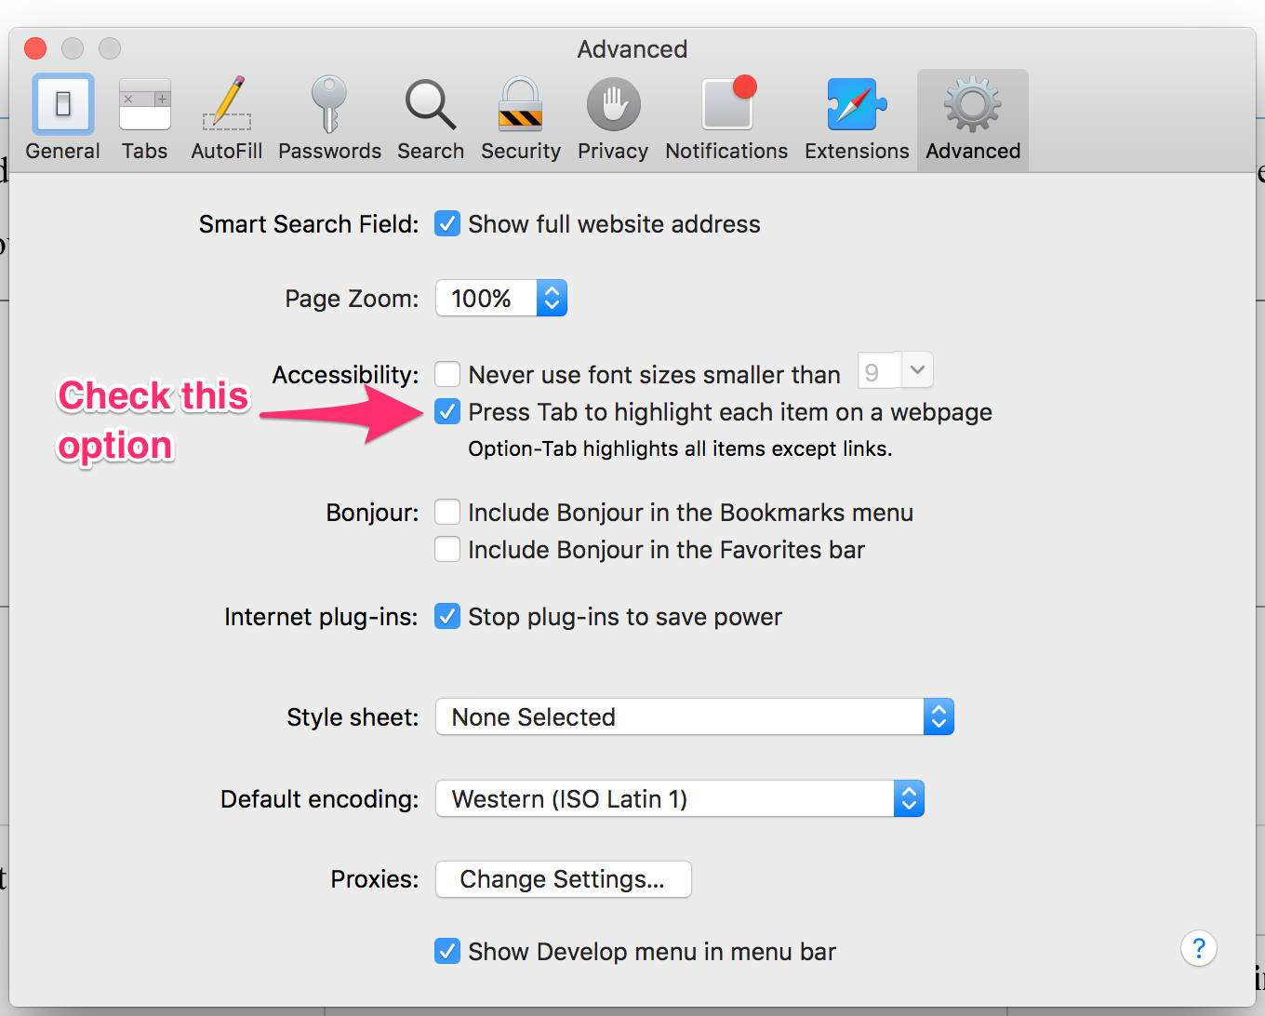

Figure : Safari Preferences to Enable Keyboard Navigation

## Auto-Request Embossing

The auto-request embossing feature was nonfunctional and required a fix. This change was necessary to complete testing, but was not committed as part of the non-merged branches because it has already been fixed by Fairway on another branch:

(<https://github.com/SmarterApp/TDS_Student/commit/2aa87bed2f6c18eb176a6f21280e54eb9babaa0d> ).

**Repository**: Student

**Package**: tds.student.web.handlers

**File**: ContentHandler.java

**Line**: 123 (incorrect):

if (prefetched && attempt == 1) {

**Line** 123 (corrected):

if (attempt == 1) {

However, it should be noted that for our version of the code, **this change fixed only the item-level auto request embossing, not the passage-level**. This is tracked internally as SB-1510 and deferred.

## Proctor Display of Student Test Settings

An issue with the proctor app was completely preventing it from displaying the student Test Settings screen. This change was necessary to complete testing, but was not committed as part of the non-merged branches because it has already been fixed by Fairway on another branch: <https://github.com/SmarterApp/TDS_Proctor/commit/3baa4be2136935d834c368d8e689337b2ac2a802)>.

**Repository**: Proctor

**File**: TestApprovalHelper.java

**Package**: TDS.Proctor.performance.utils

**Line** 133 (incorrect):

if (oppInfo.getOpportunityId() == ( acc.getOpportunityId()))

**Line** 133 (corrected):

if (oppInfo.getOpportunityId().equals( acc.getOpportunityId()))

## Missing Top Border in Test Review Screen

On the iPad running iOS 8.1.2, the test review screen which lists the test questions, is missing the top border from the question numbers. This is being tracked internally as SB-1511.

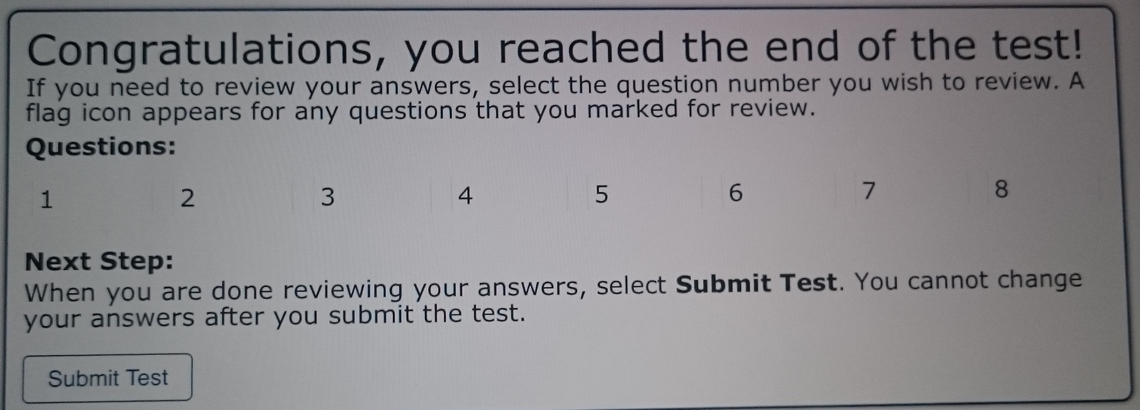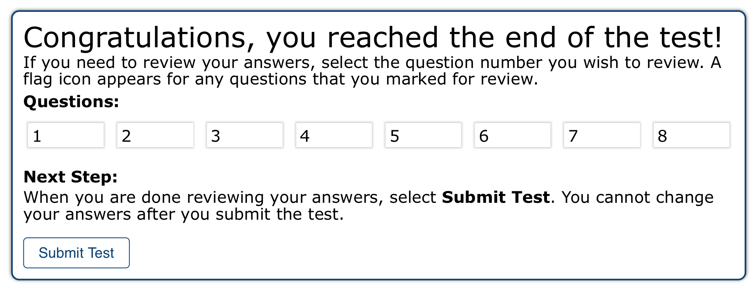

Figure : iPad review screen (left) vs. other browser (right)

# Appendix A: Before and After Student Screenshots

## Login Page

1. Login page theme should match with Smarter Balanced Theme  
   * NO Changes

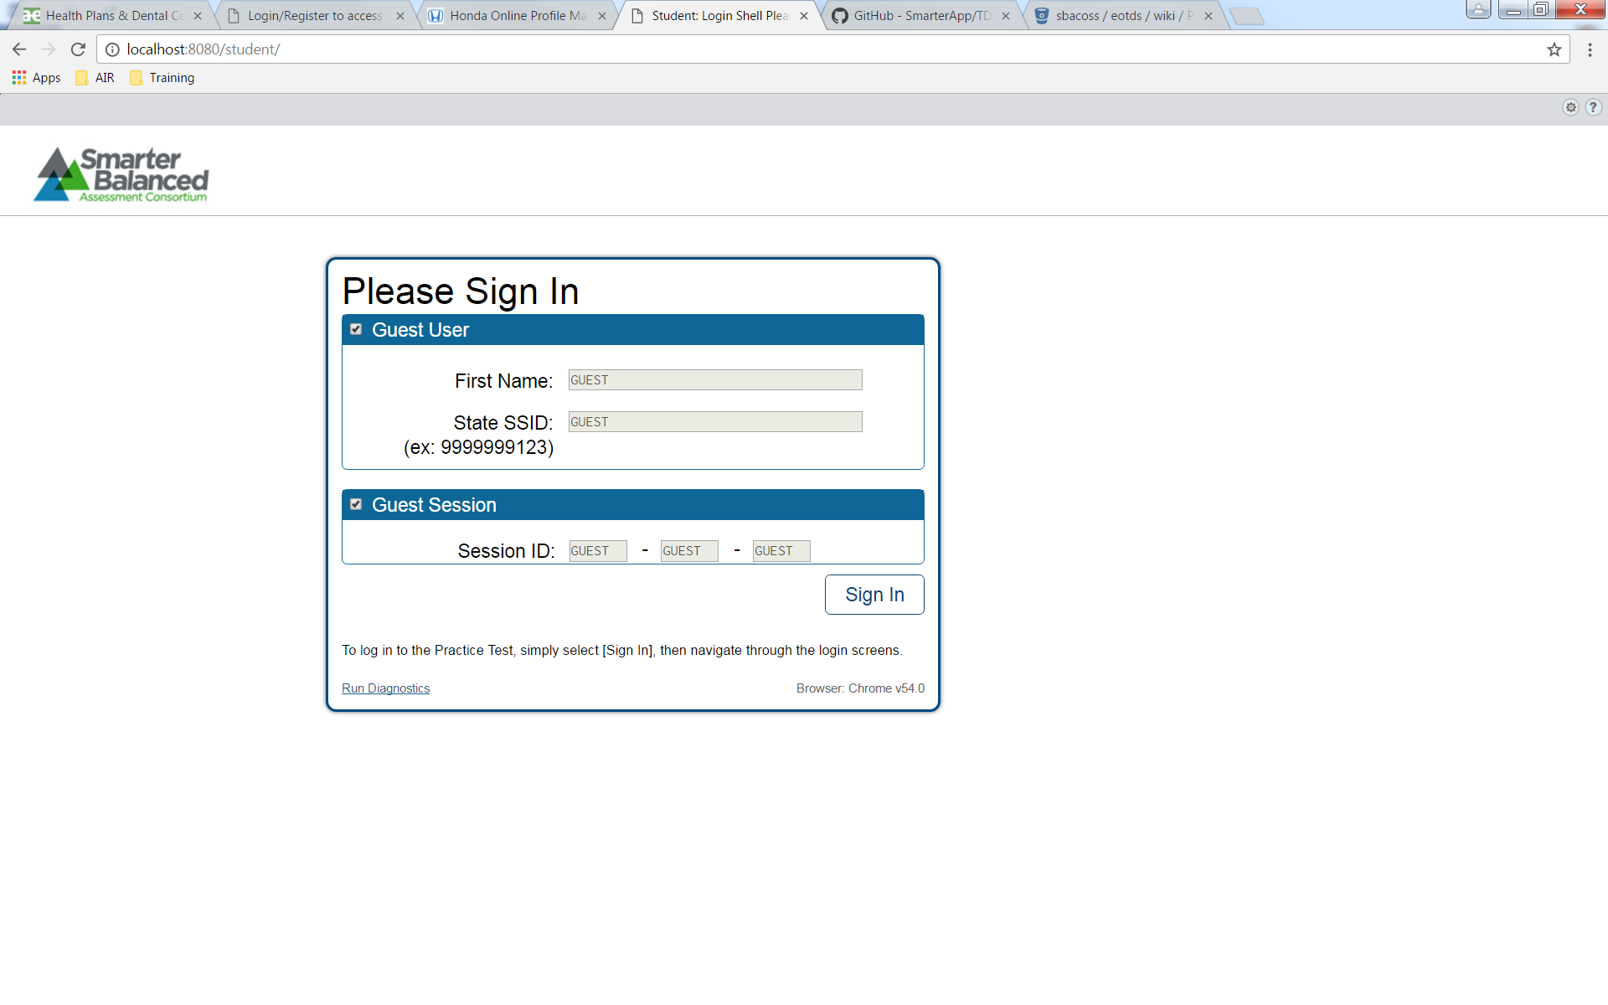

1. On Click of Setting Icon of top right it should provide option to change settings

Before:  
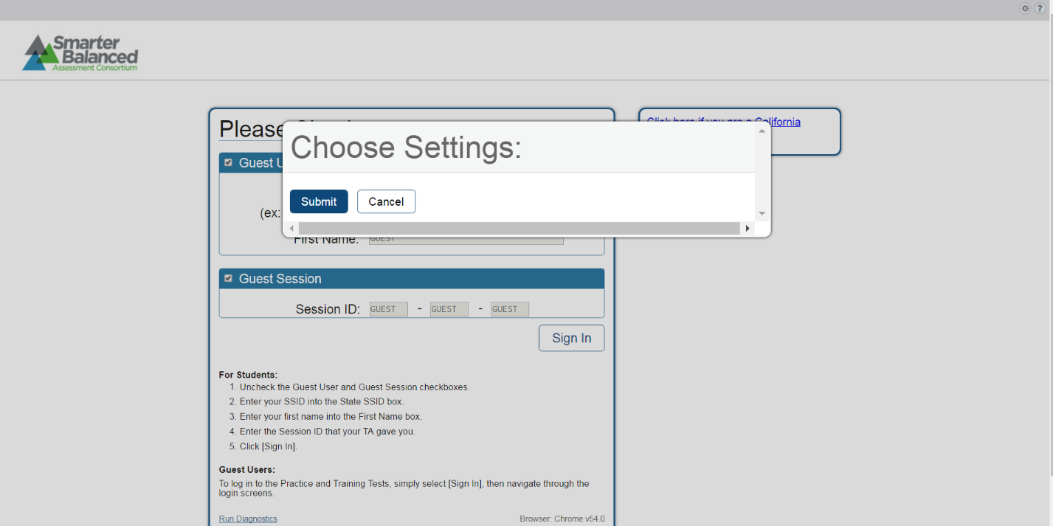

After: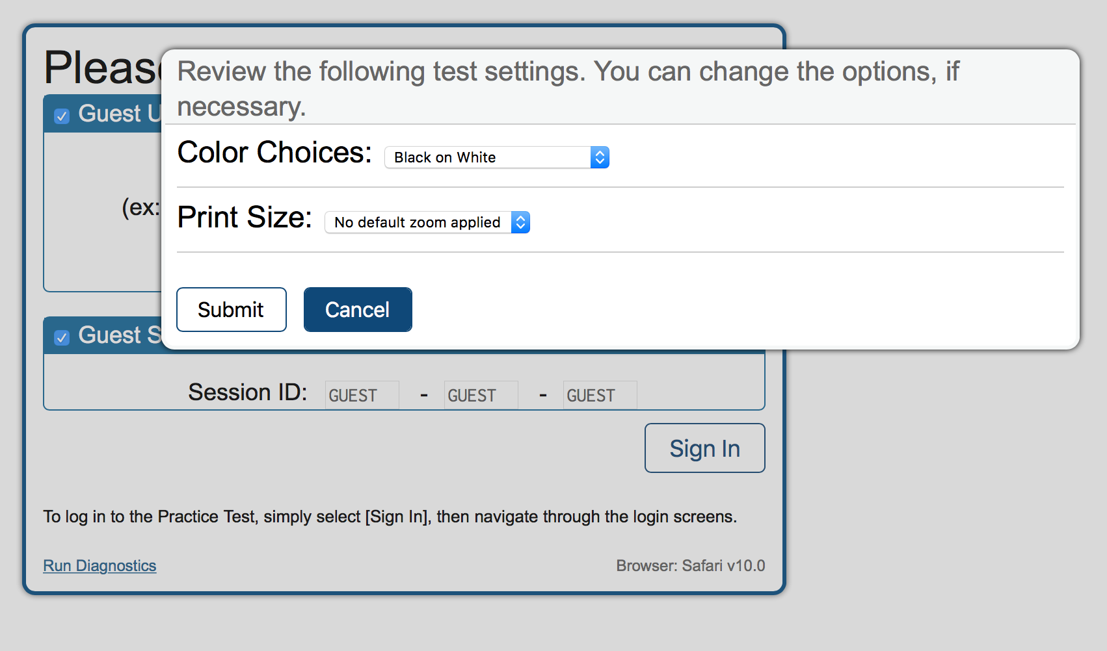

1. On Click of Help Icon it should open up Help Guide

Before: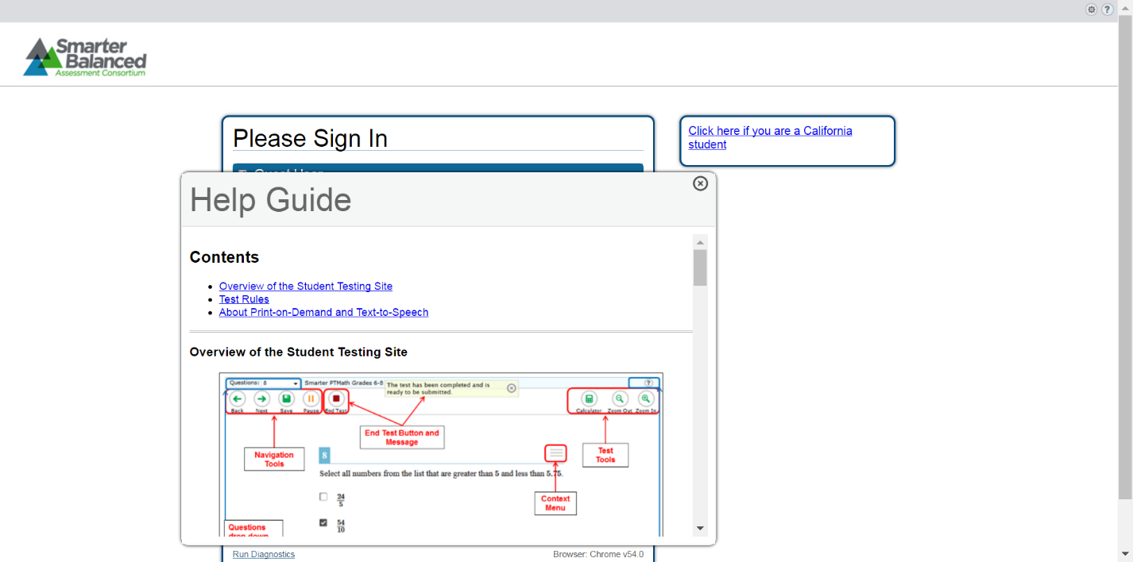

After:

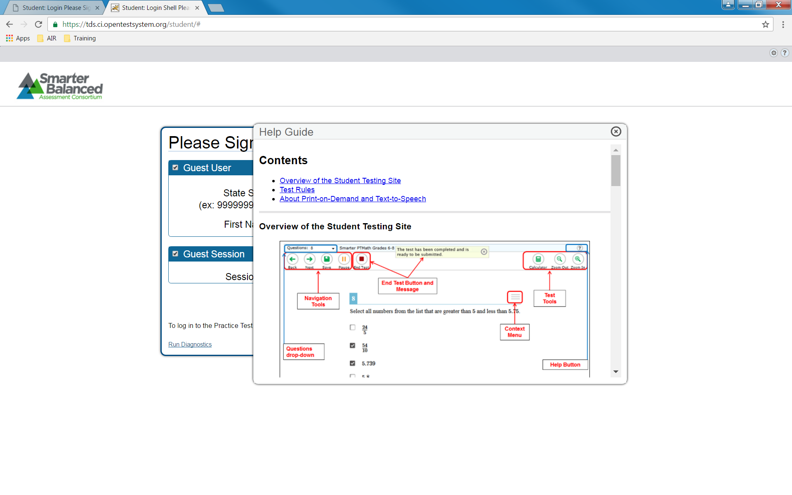

## General CSS and Page Layout

* 1. Each page should be divided into three sections as shown below - Top, Center & Bottom.
  2. Header and footer information should match as per screenshot.
  3. All positive feedback button should be on left and in blue, while the negative feedback button is on the right and in red.
  4. All popup warning or attention messages should have positive feedback on left and negative on right.

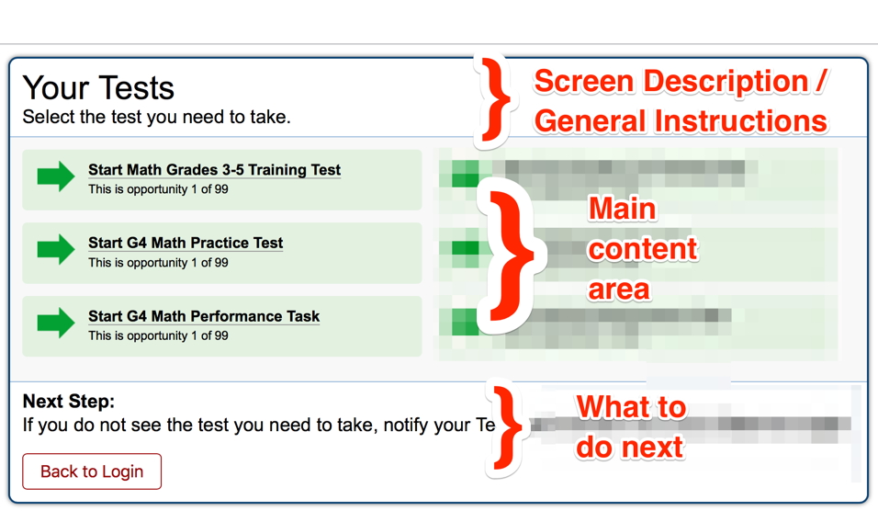

## Login Verify

Before:  
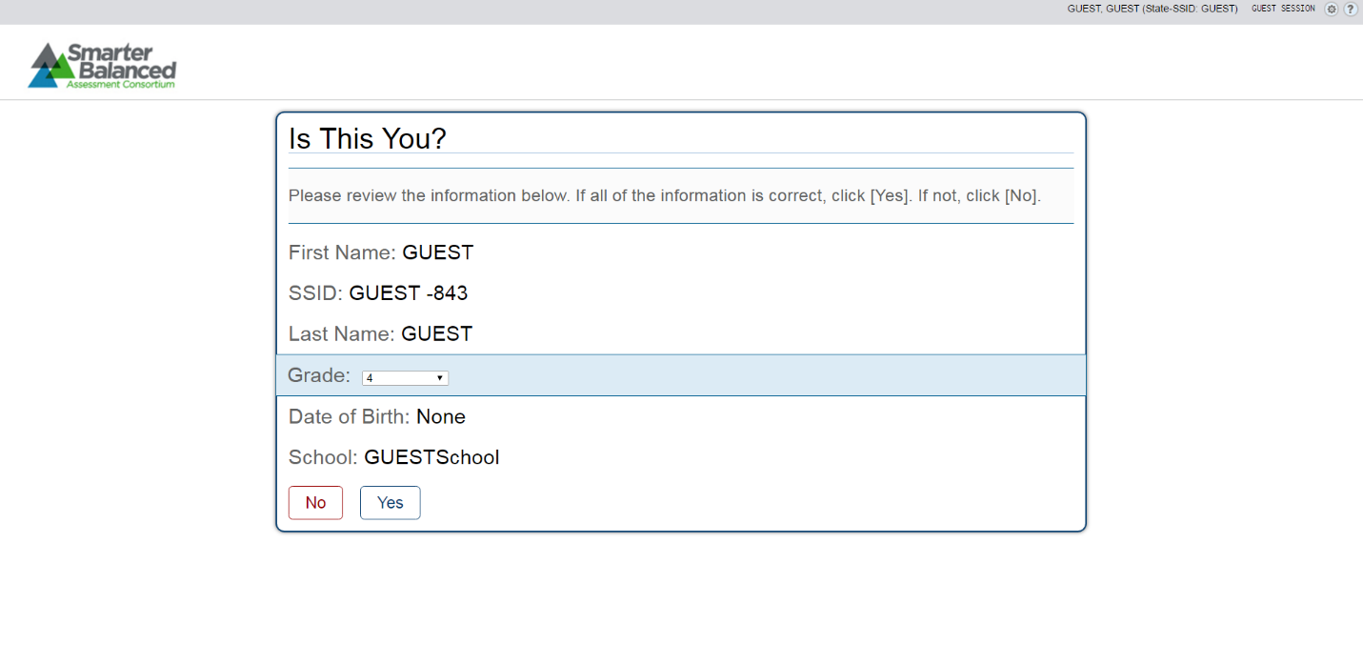

After: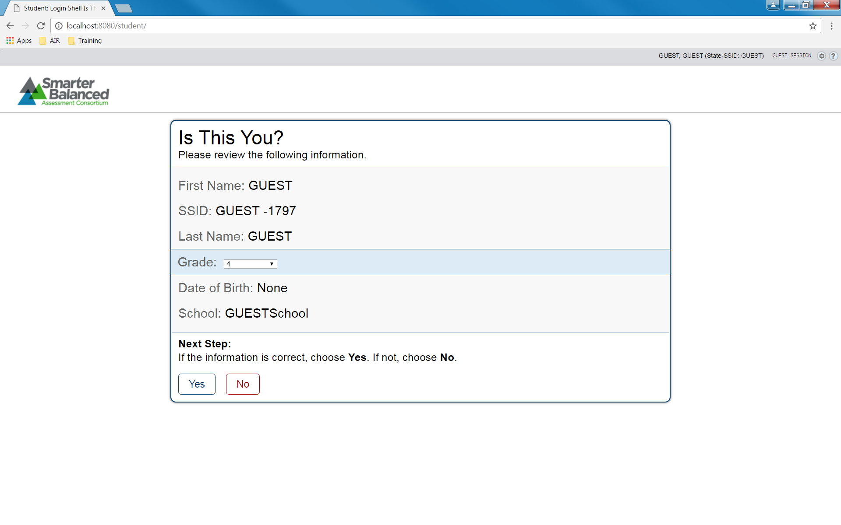

## Test Selection Page

Before:  
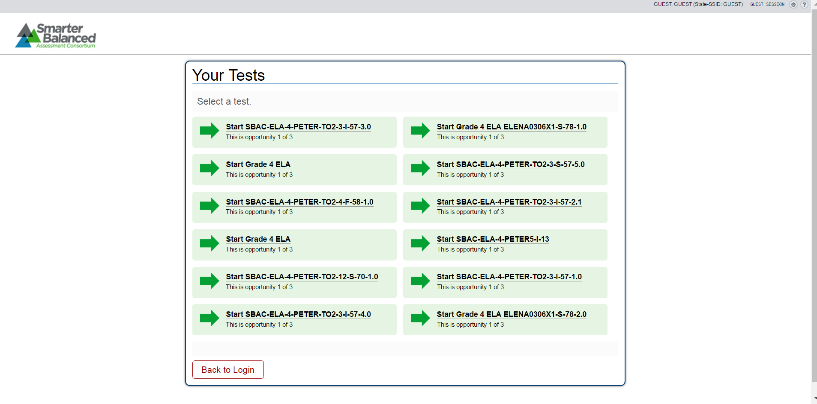

After: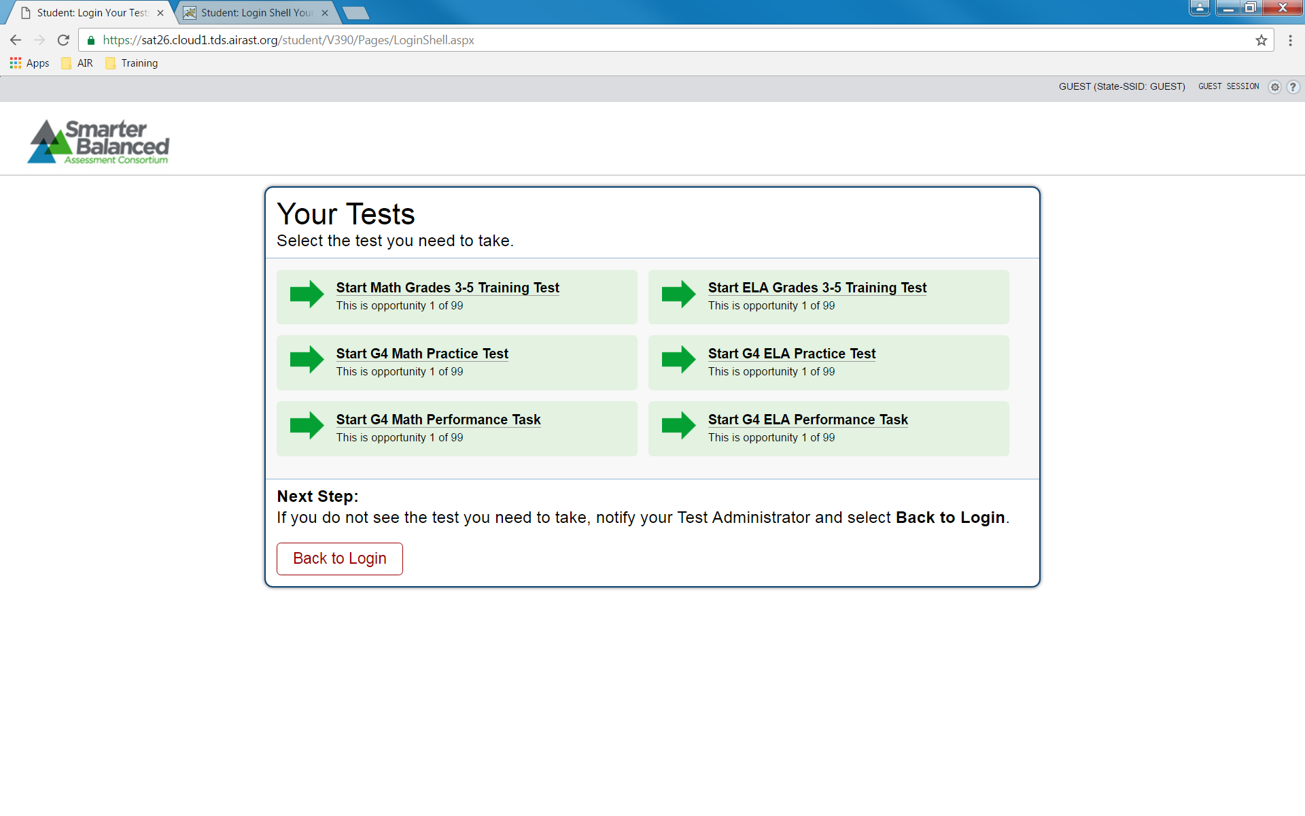

Before:  
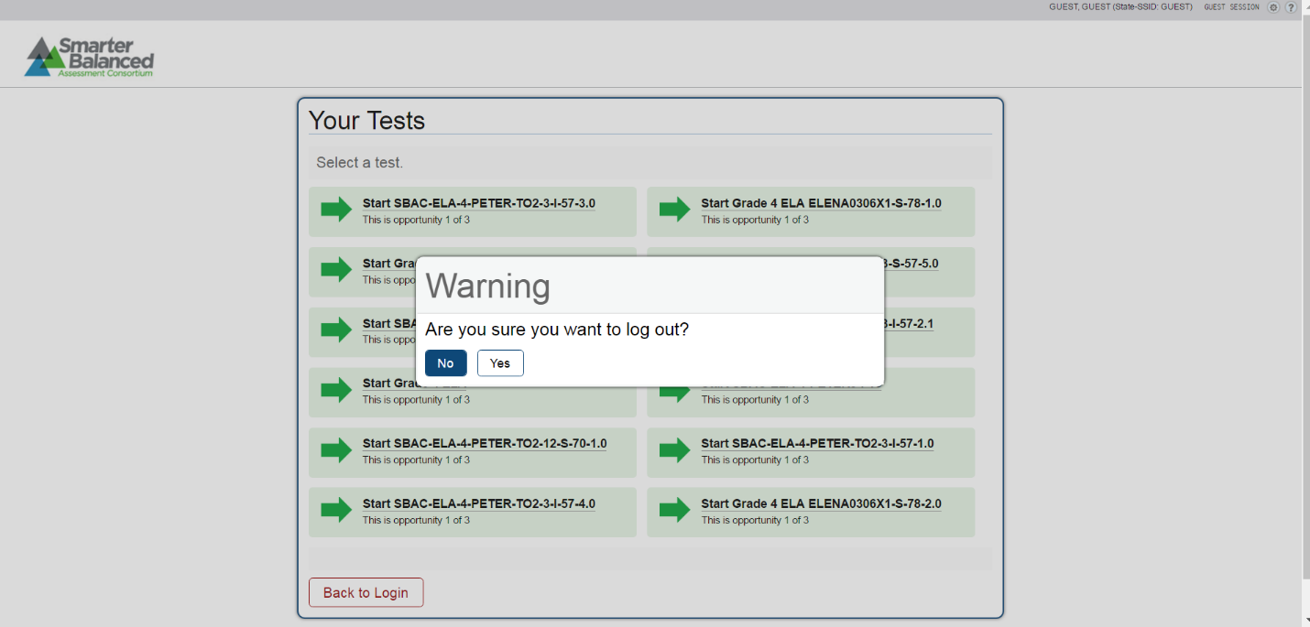

After: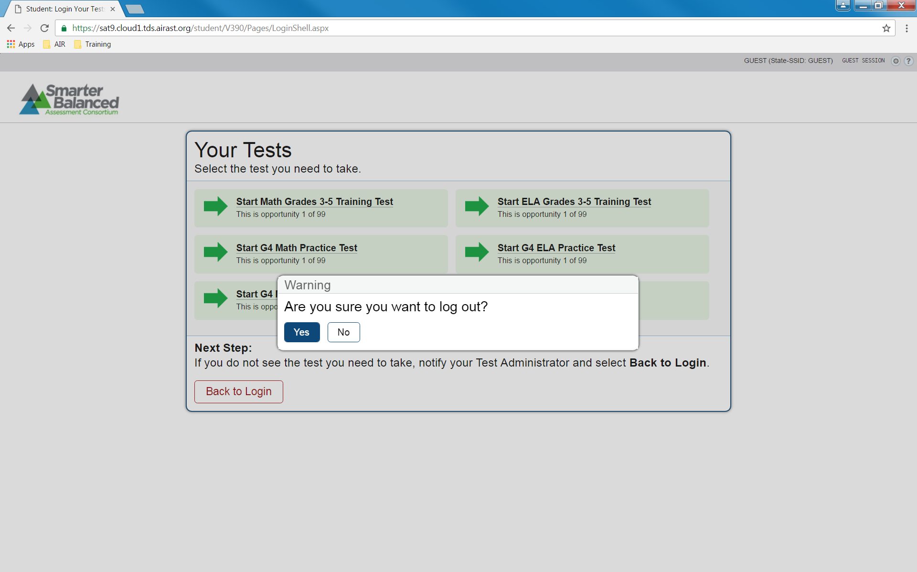

## Accommodation Selection Page

Before:   
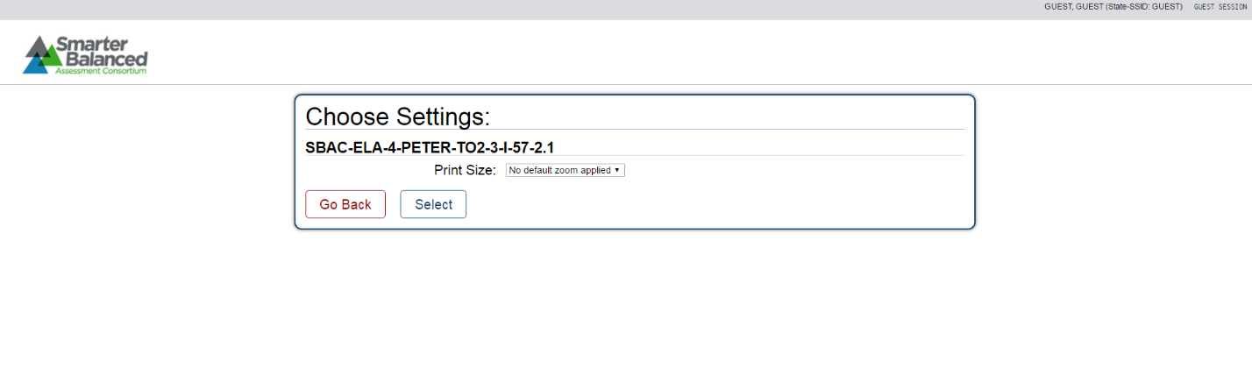  
Note: The number of available settings depends on configuration. Screenshots are showing difference in added footer and different order of buttons.

After: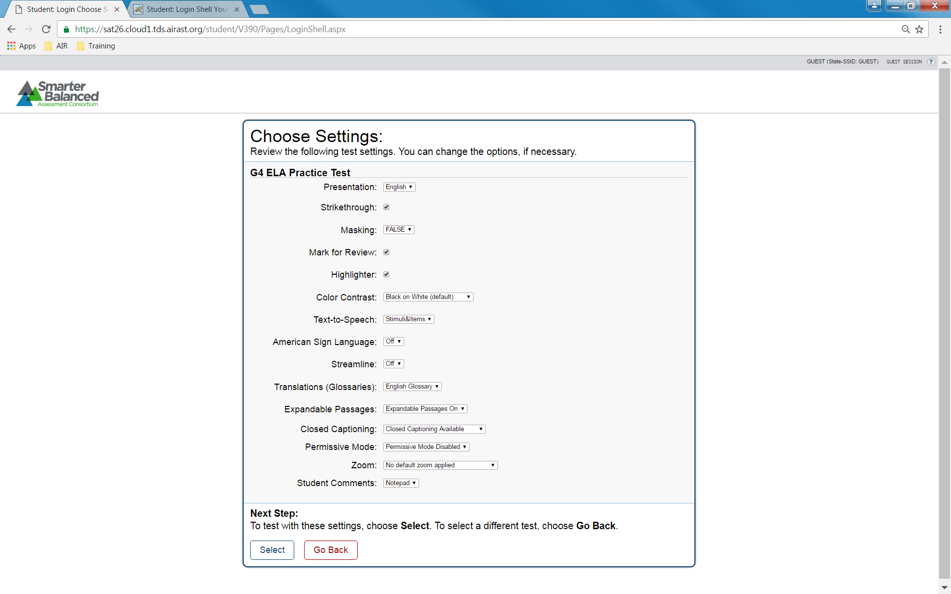

## Confirm Accommodation selection

Before:   
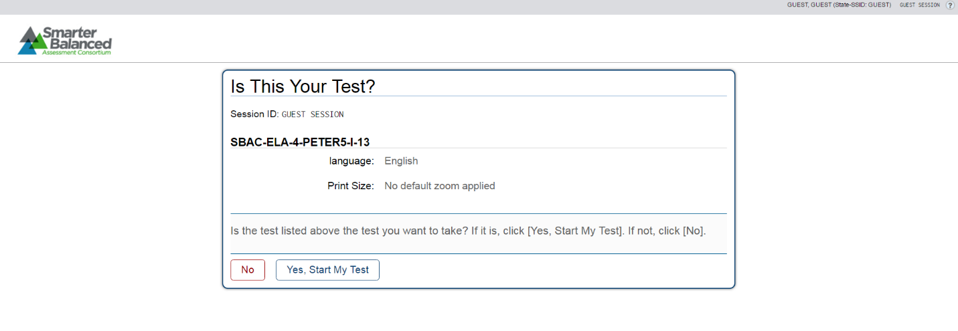  
After: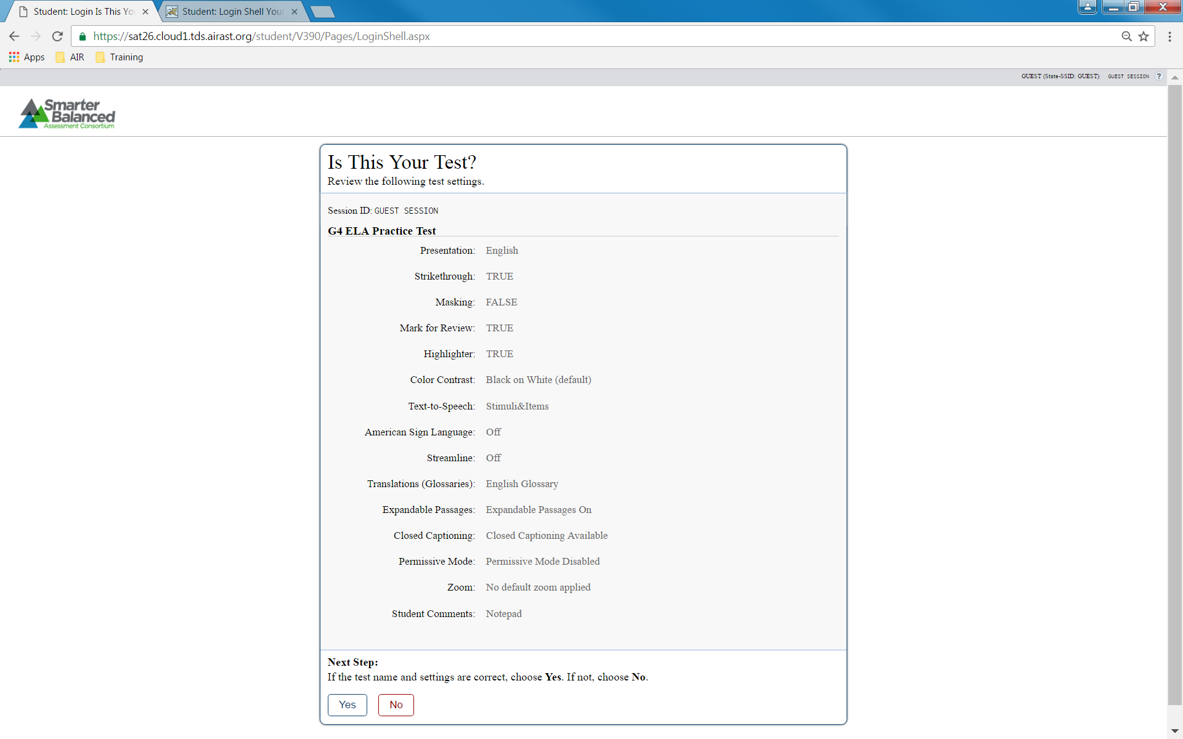

## Audio Playback Check Page

Before: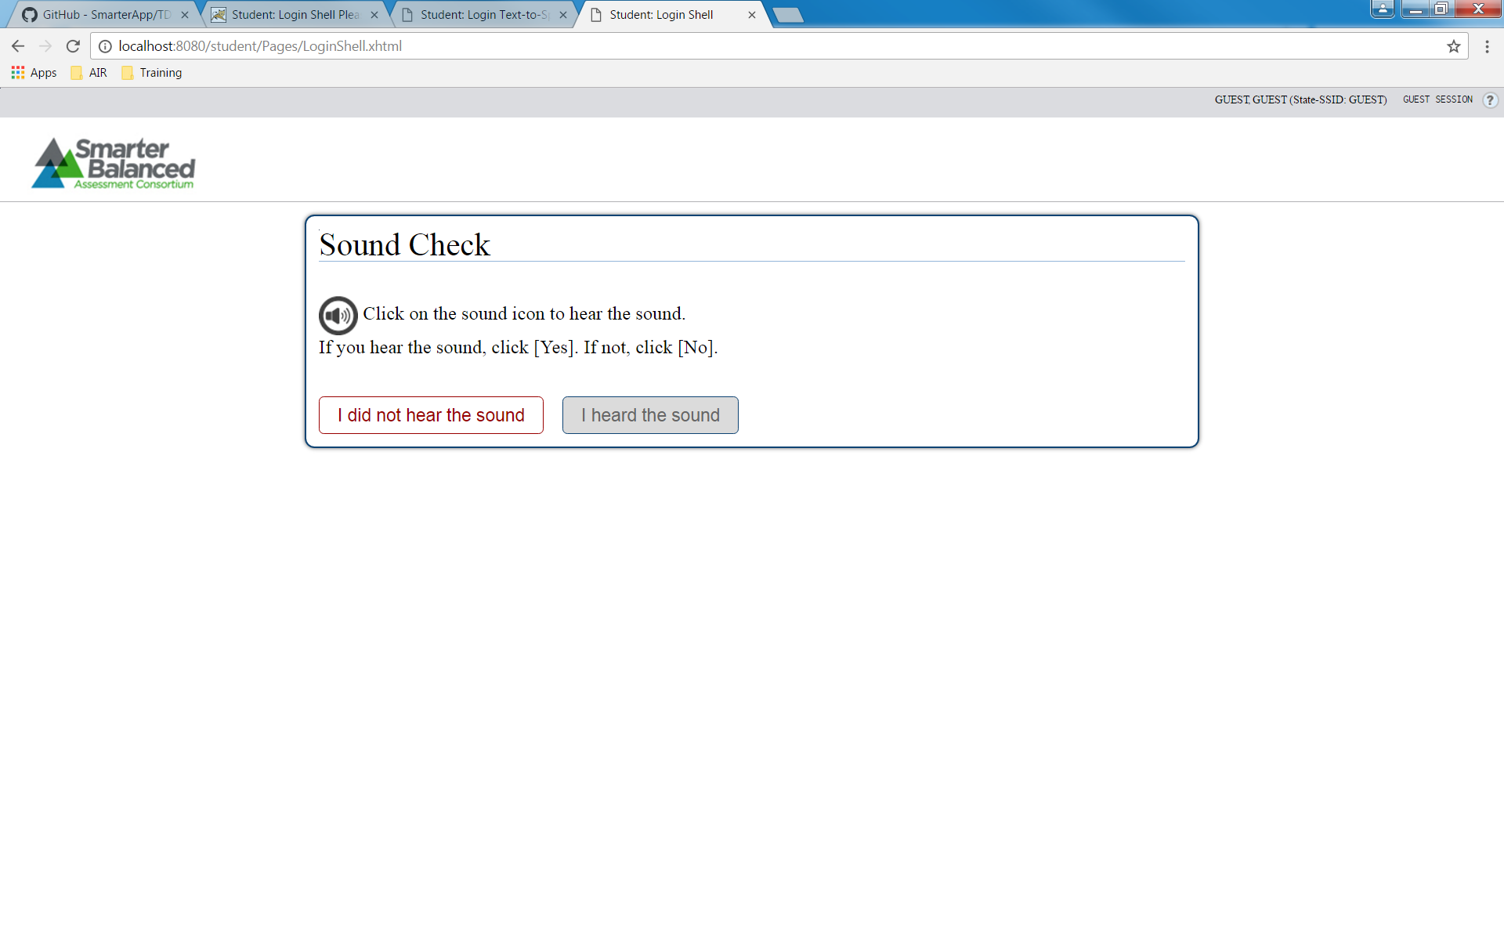

After: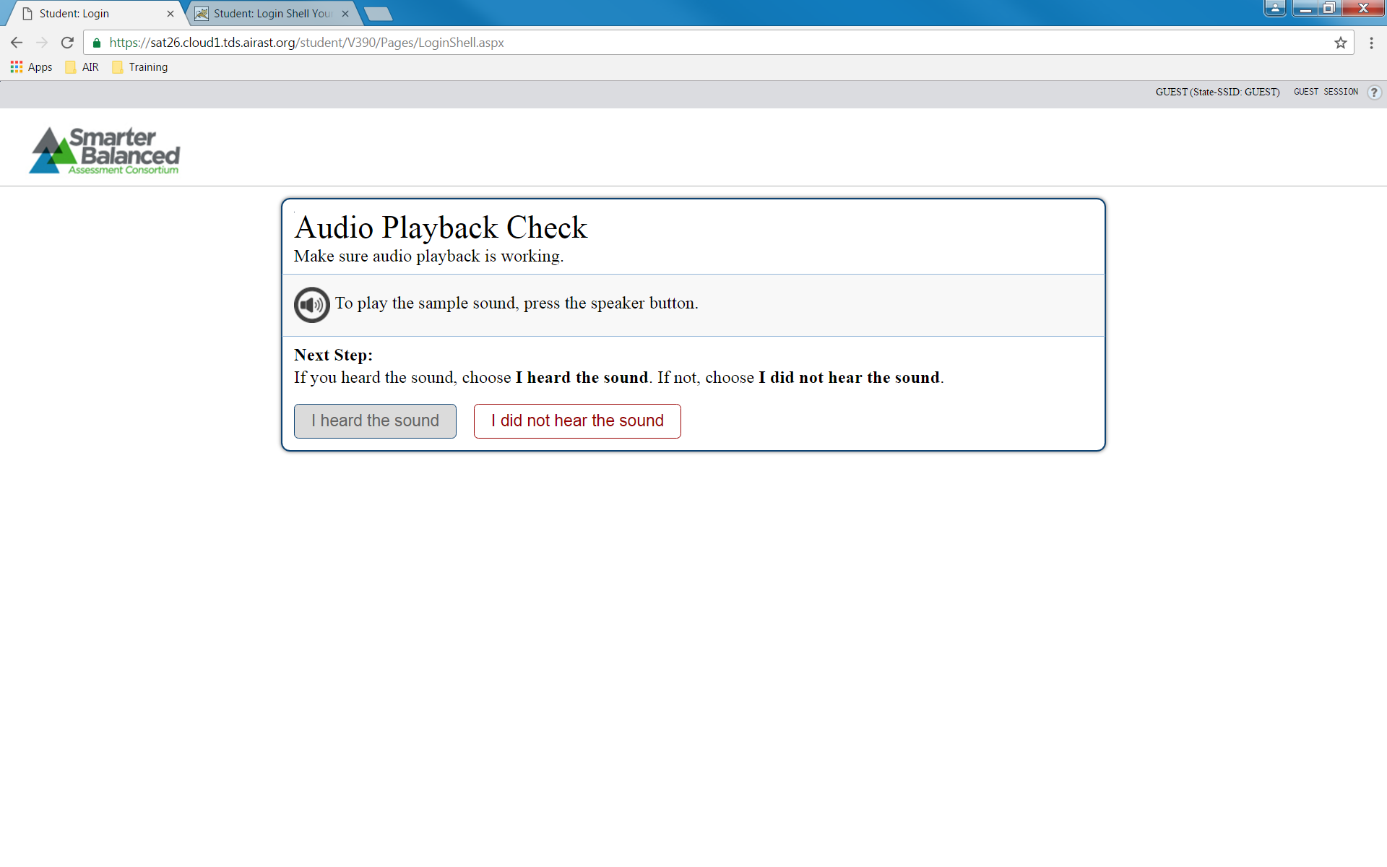

## Sound Check: Audio Problem

Before: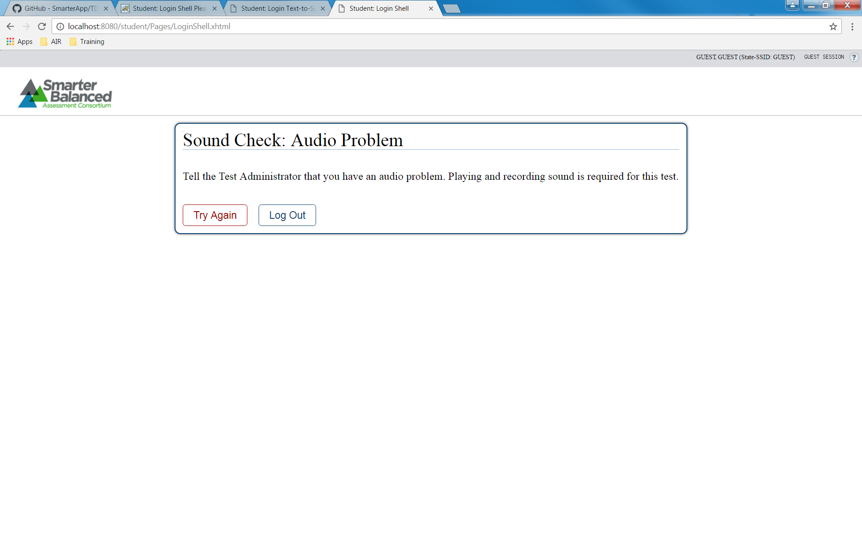

After: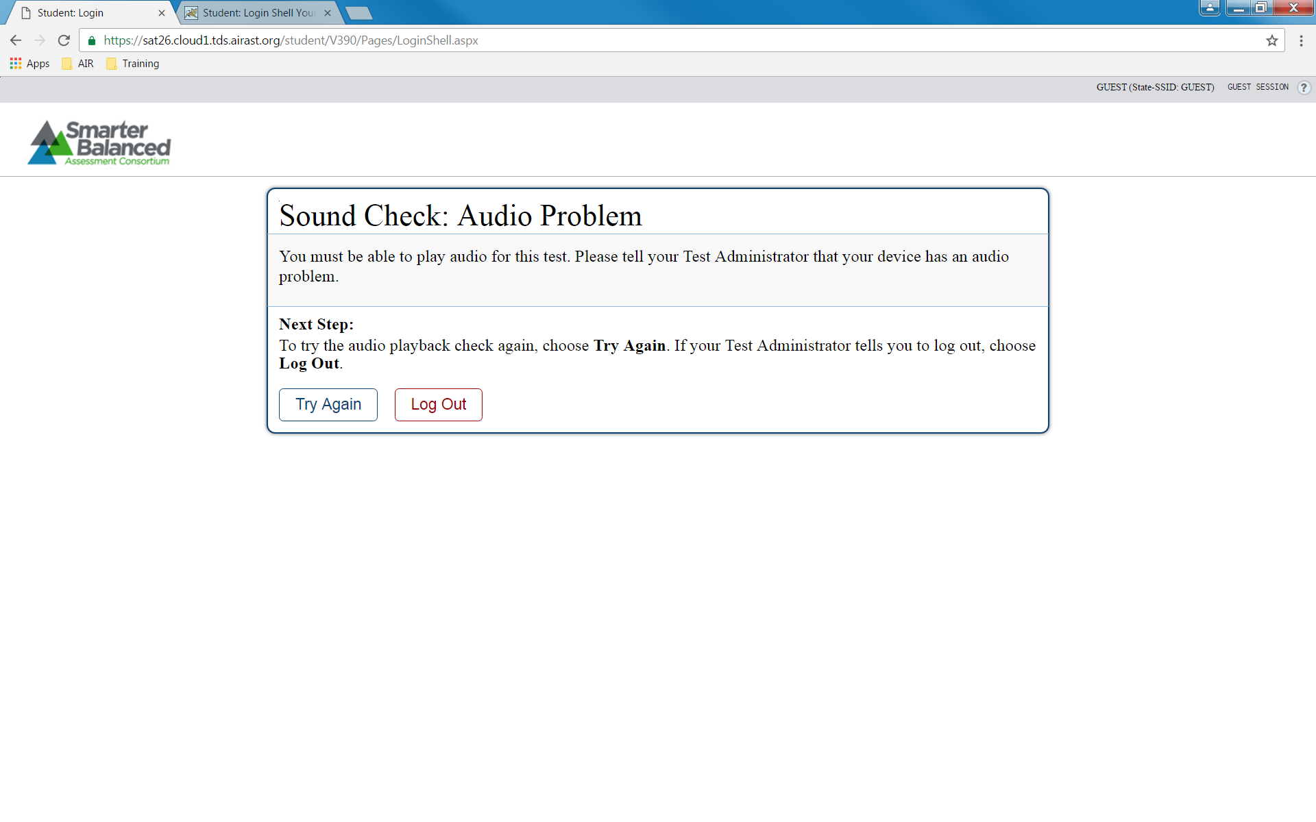

## Text-To-Speech (non-secure browser)

1. TTS is not available in a non-secure browser. If a user enables TTS and uses a non-secure browser, user should get the error message below:

Before: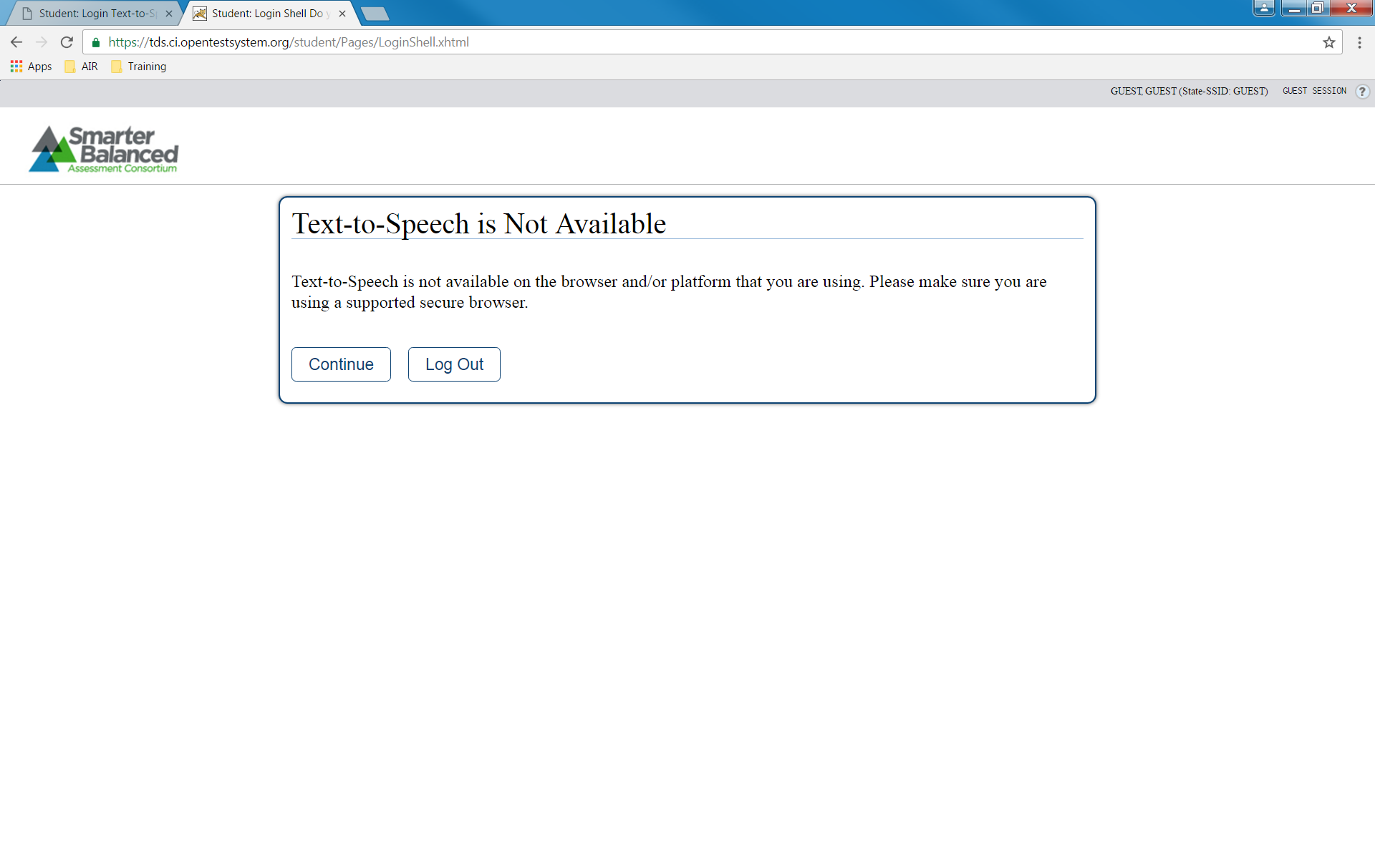

After: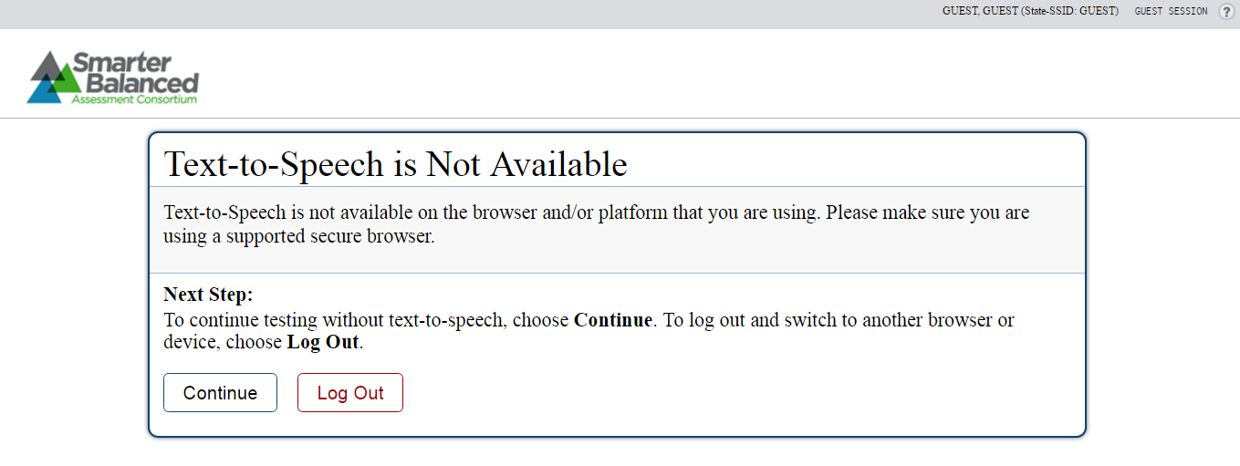

## Text-To-Speech (Secure Browser)

1. TTS is available in secure browser only, so the below pages are only available if user is using a secure browser.

Before:

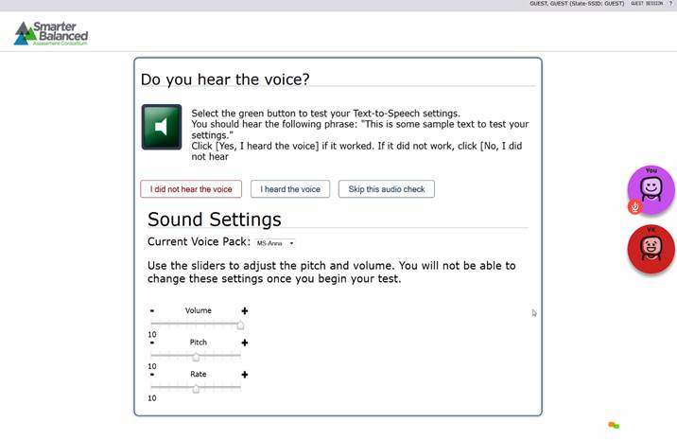

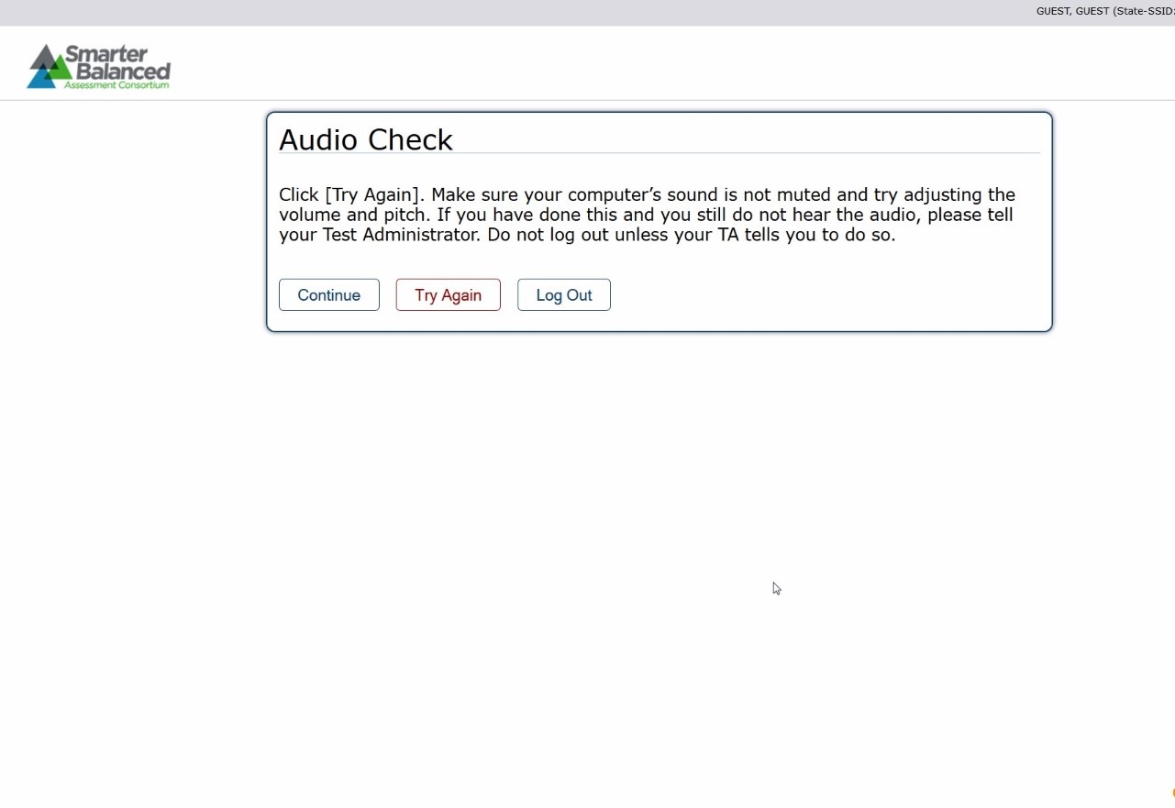

After: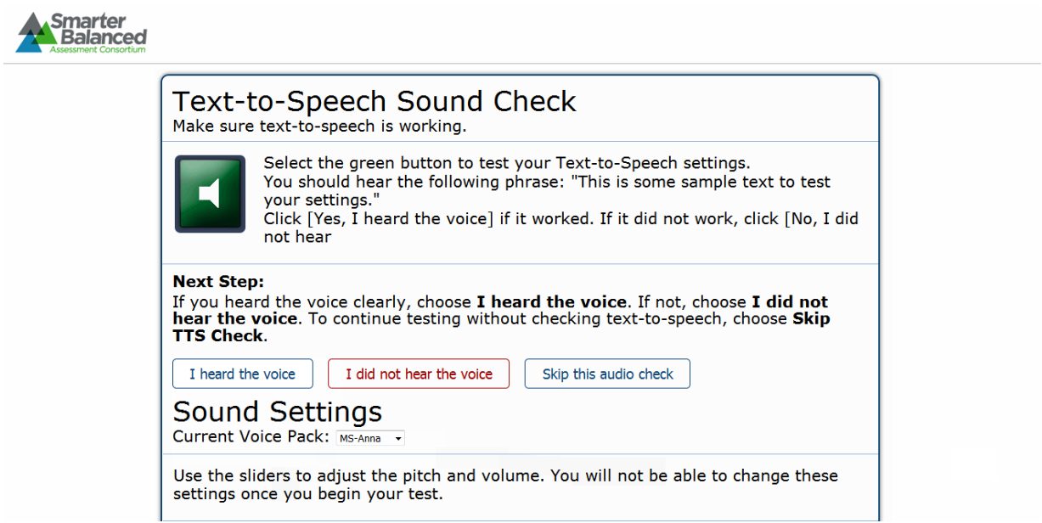

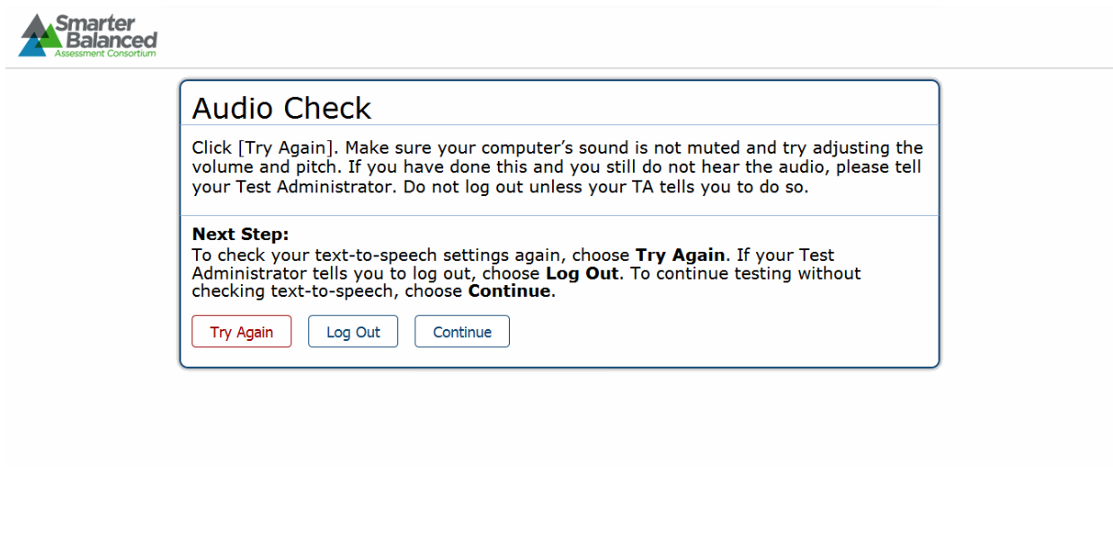

## Help Page

Before:  
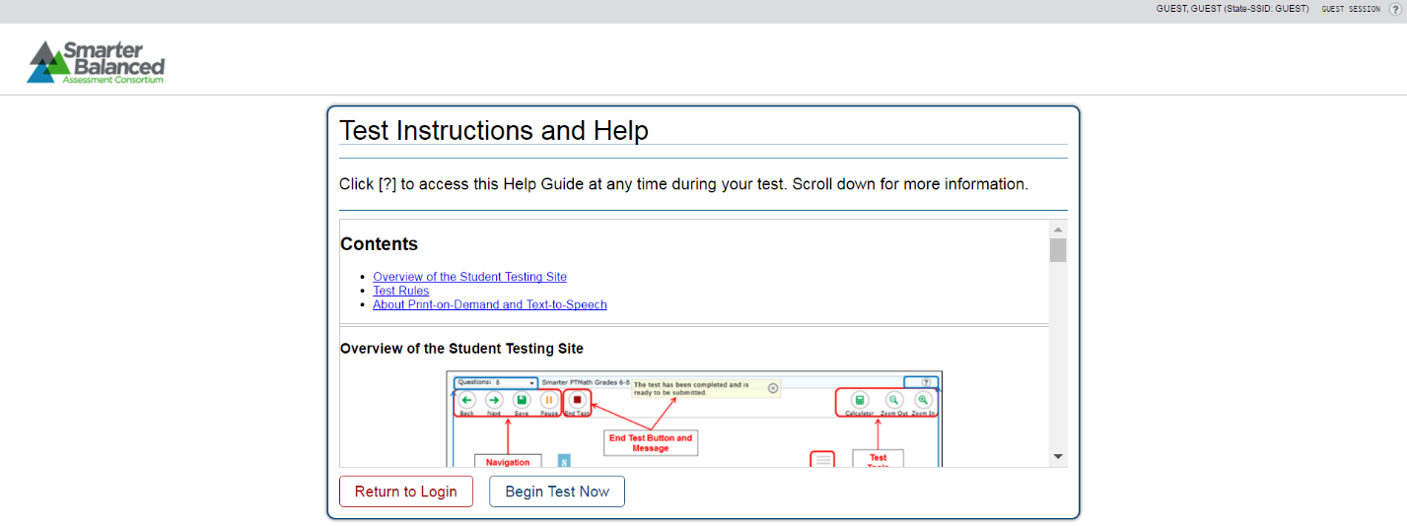

After: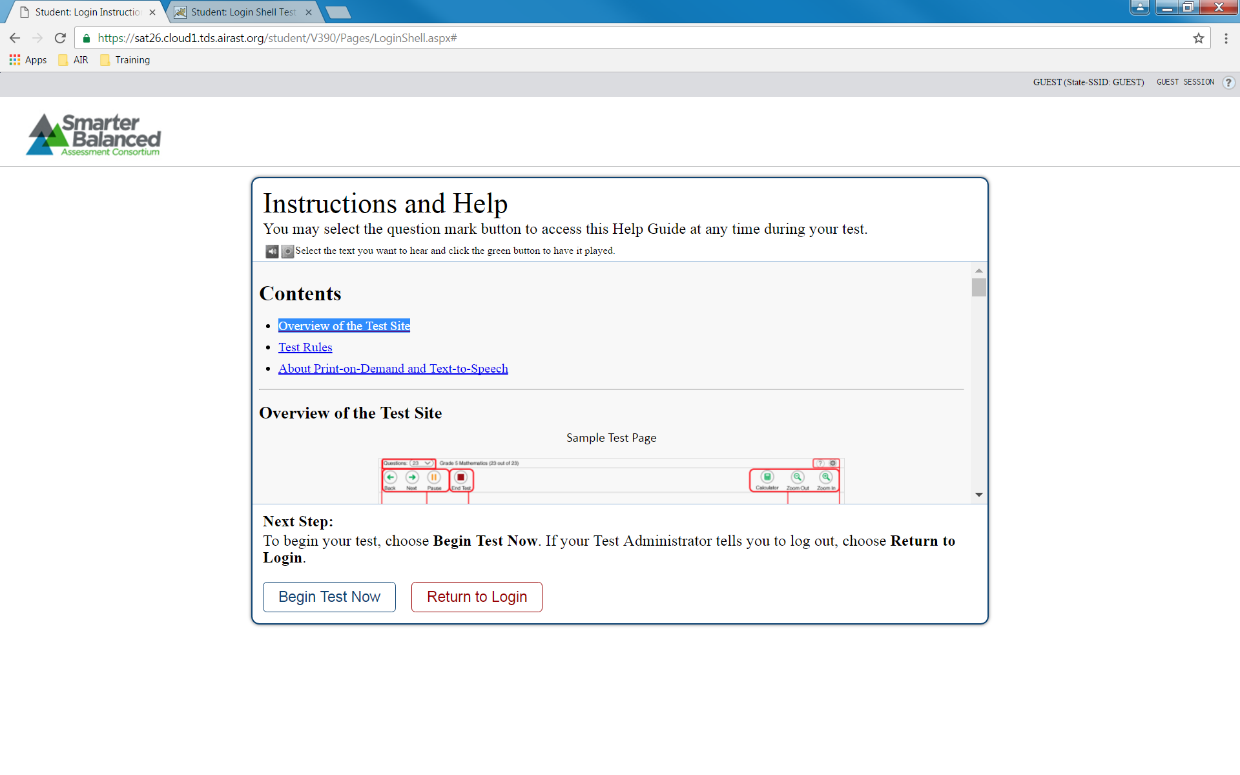

## Test Page

No changes

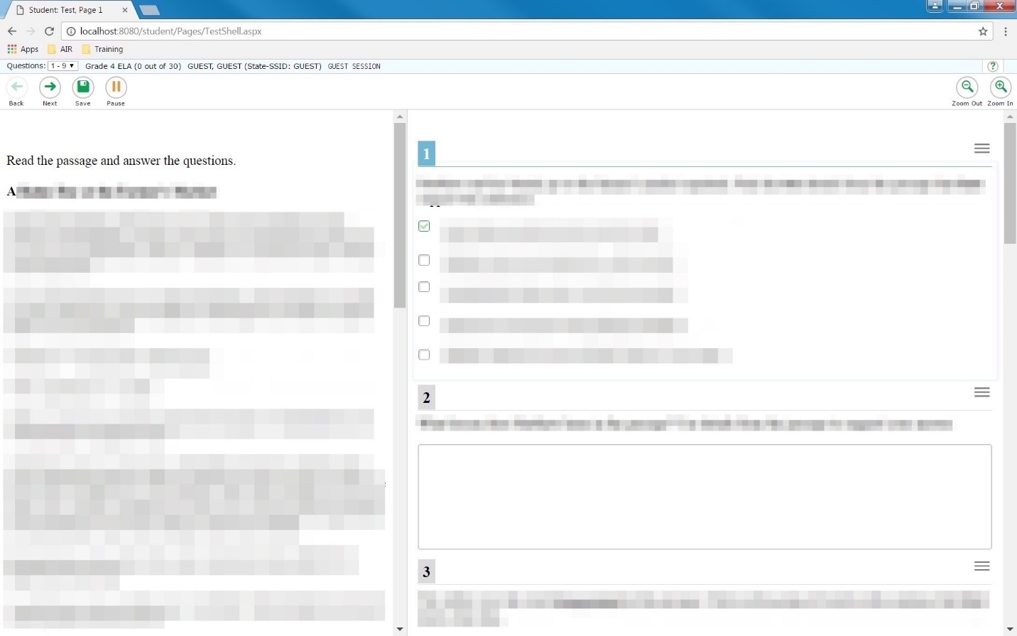

## Review Page

Before:  
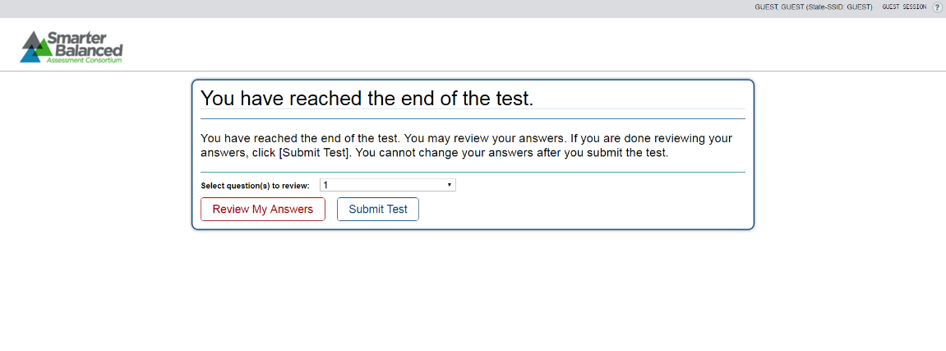

After:

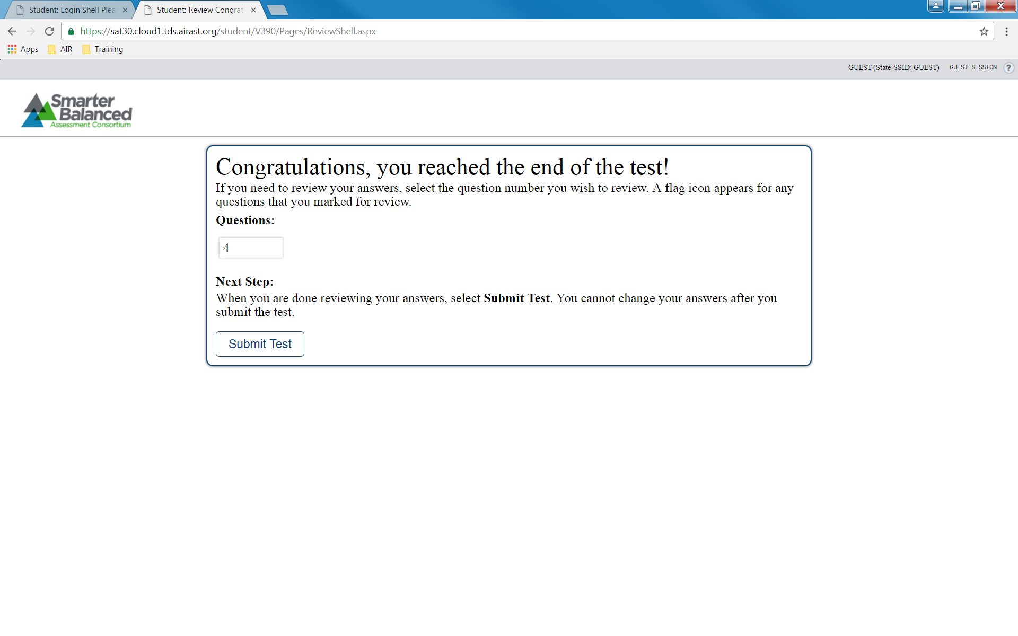

## Result Page

Before:  
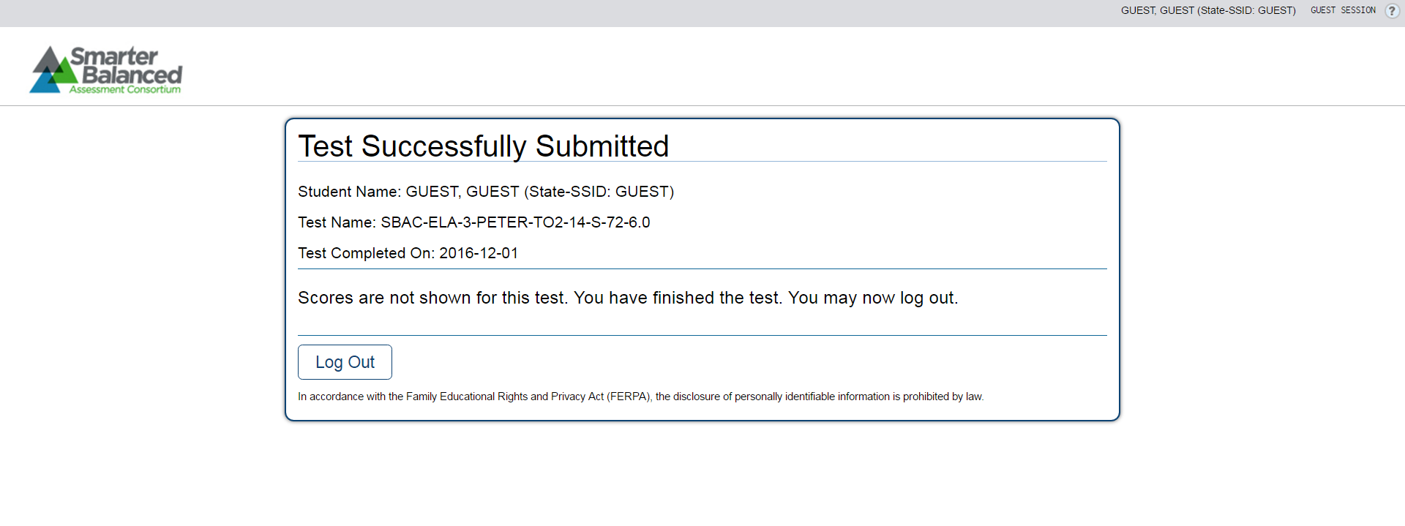

After: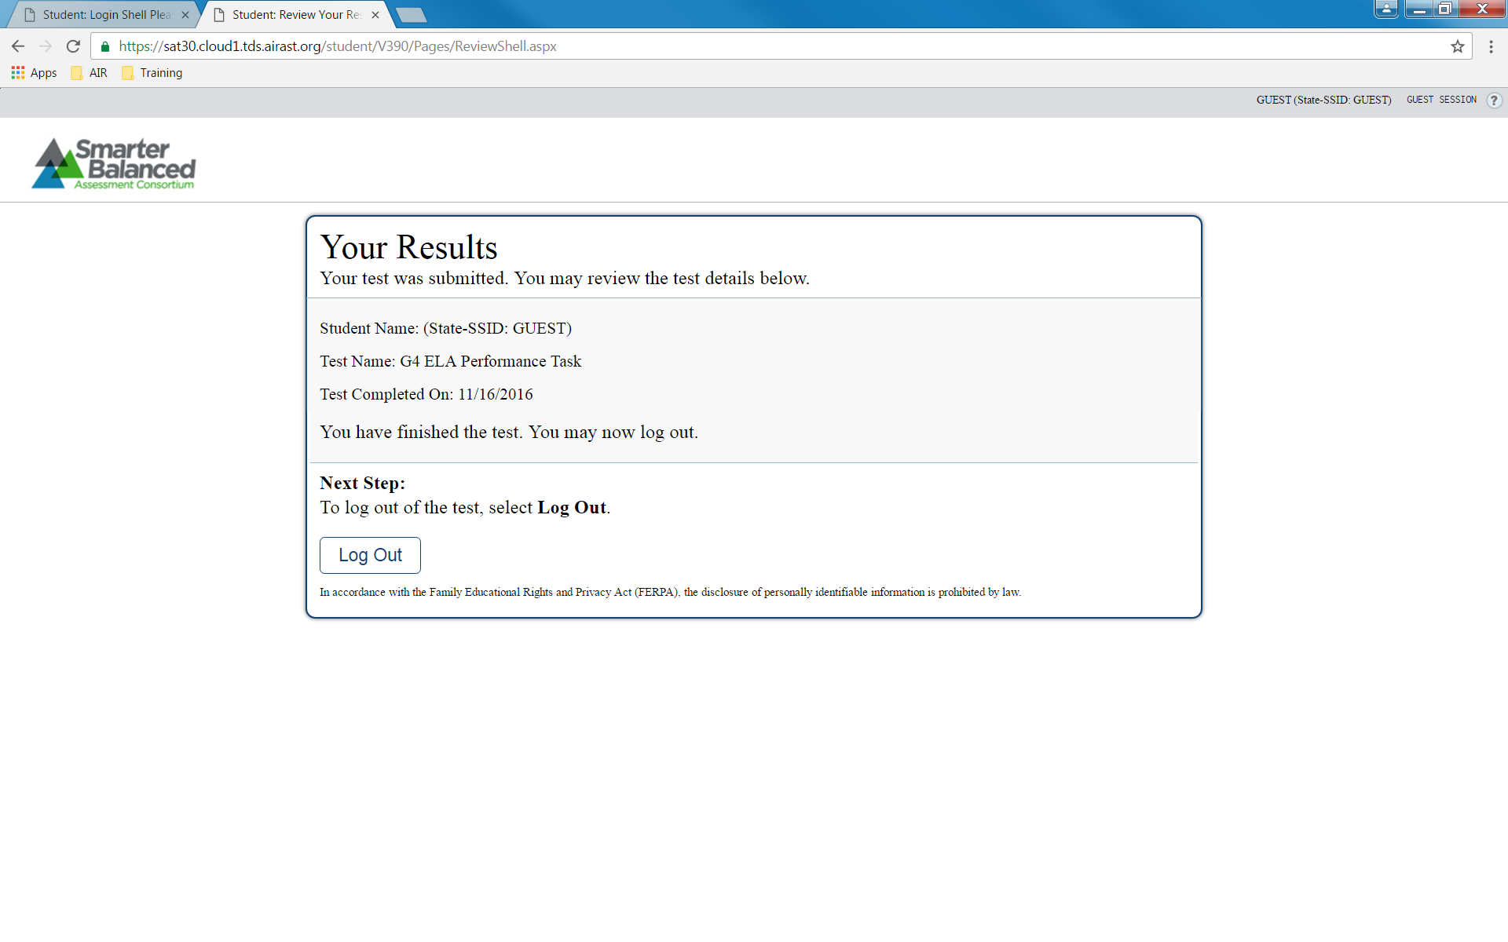

# Appendix B: Code Change Summary

|  |  |  |
| --- | --- | --- |
| **GitHub Repository** | **Change Summary** | **Tracking ID** |
| SmarterApp/ TDS_TestDeliverySystemDataAccess | Restructuring of the Student Interface UI | SB-1505 |
| SmarterApp/TDS_Student | Student Help Guide Updates | SB-1503 |
| SmarterApp/TDS_Student | Navigational Improvements for Next Button | SB-1504 |
| SmarterApp/TDS_Student | Restructuring of the Student Interface UI | SB-1505 |
| SmarterApp/TDS_Student | Intelligent Muting Capability | SB-1506 |
| SmarterApp/TDS_Student | Elimination of Unused Dependencies | SB-1509 |
| SmarterApp/TDS_Proctor | Elimination of Unused Dependencies | SB-1509 |
| SmarterApp/TDS_ItemScoring | Elimination of Unused Dependencies | SB-1509 |
| SmarterApp/TDS_ItemRenderer | Navigational Improvements for Next Button | SB-1504 |
| SmarterApp/TDS_ItemRenderer | Restructuring of the Student Interface UI | SB-1505 |
| SmarterApp/TDS_ItemRenderer | Intelligent Muting Capability | SB-1506 |
| SmarterApp/TDS_Administrative | Allow test type bypass for loading registration packages | SB-1508 |
| SmarterApp/TDS_Student | Task Documentation | SB-1442 |

Figure : Summary of Repository Changes

Finally, for repositories where changes constituted more than one branch, a merged version of the changes was created, labeled **TaskOrder-24**.

1. BACKGROUND: All system sounds were muted by Smarter policy for ELA tests (to require students to use the Braille / Refreshable Braille Display to read the question). NFB's stance was that this was disadvantageous for students who were not fluent in Braille, and that it should be made possible to have JAWS read some or all of the q/a text.